Manifold Learning-Based Prediction and Stability Analysis of Lentil (Lens culinaris Medik.) Grain Yield Across Multiple Environments in Drought Condition

Abstract—Prediction of lentil (Lens culinaris Medik.) grain yield in different environments is still challenging due to the complexity of genotype × environment interaction and the nonlinear nature of agronomic traits. We combined manifold learning, machine learning, explainable AI (XAI), and genotype stability analysis to evaluate lentil performance under drought-prone conditions in northern Bangladesh. UMAP and t-SNE based on 150 observations on ten genotypes from five environments revealed trait patterns and environmental groupings. The model performance was assessed by cross-validating twelve regression models and the best performing algorithm was chosen using nested cross-validation . The best algorithm was the ridge regression with test R2 of 0.8072 and root mean square error (RMSE) of 183.77 kg/ha. The model had good generalization ability from cross-validation (R2 = 0.7289 ± 0.0177). SHAP analysis indicated that DF_BP_Interaction and TSW were important for predicting yield. The AMMI and GGE biplot analyses suggested G71 and G63 as relatively stable genotypes, while the G49 genotype had the highest average yield (1682.28 kg/ha) but only moderate stability. The GGE biplot also seemed to split the site into two mega-environments and Shyampur (L2) had the highest mean yield (1705.5 kg/ha). In summary, interpretable machine learning combined with stability analysis could improve genotype selection and yield prediction.

Keywords—Lentil yield prediction, machine learning, SHAP, AMMI/GGE biplot, stability analysis, yield stability analysis, ridge regression.

1. Introduction

A tiny disk-shaped seed known as a lentil thrives when temperatures drop. spreading through temperate zones thanks to its rich supply of protein, dietary fiber, and essential vitamins that help balance glucose in the bloodstream [27]. Since these crops capture atmospheric nitrogen, improving soil quality naturally, they slot smoothly into farming systems dependent on seasonal rains, particularly in worn-out earth needing fresh life and diverse planting patterns [3], [9]. With worldwide interest increasing in vegetable-based nourishment and more powerful diets, researchers now drive harder harvests of lentils forward in experimental plots and controlled environments worldwide. And still, each field's output is tightly tied to complex webs: genetic traits slamming into rain cycles, physical characteristics folding together weirdly, and weather suddenly veering off course. Simple tools like linear models hit a limit when data curves rather than moves in a line. These older ways want things neat, and so they wrestle with the actual messiness. Predictions for things such as what crops to plant, or how to adjust fields, fall flat without flexibility. That rigidity turns subtle signals into guesswork. Results are fuzzy when precision counts most [1], [12].
Things are tense, different, out in the fields of Bangladesh. When the rains fail for weeks on end, farming becomes a gamble no one can win. Normal seeds like wheat, rice, or even beans often don't sprout or yield anything worth harvesting in this arid environment. But lentils, somehow, make it when most plants fail. They survive where others fall. Lentils are cultivated in dry lands across Bangladesh [10]. This one keeps bearing where other seeds fail. That edge hints at its role in adapting to tough weather patterns across the nation. Now my work is looking beyond just how much is harvested. What matters is knowing which lentil varieties stay stable as conditions change from place to place. Some cope better with drought; this study closely tracks those differences. Consistency is when a variety produces similar yields with little rain. Once soils dry out, the performance gaps show up. Each place offers more clues to resilience. One kind may thrive, others may die out. The real test is consistent results under pressure. Rain shortages impact each growing season differently. A good plant can withstand those variations. Bit by bit it becomes better to match the right kind to hard zones. The findings suggest choices that endure through extreme seasons.
Lately, machines that learn have stepped into the spotlight for guessing how much farms will harvest. When plant features tangle with weather and soil in unpredictable patterns, they make sense of chaos better than most. Models such as Random Forest or XGBoost [13], [14] tend to beat traditional approaches at this task. Yet, despite strong guesses, plenty of researchers hold back full confidence, since these systems decide in silence, never explaining why. Figuring out reasons counts just as much as spotting results for those growing plants or handling farmland. Enter SHAP [15], [16], which pulls apart forecasts one chunk at a time, making computer outputs easier to grasp and apply. Alongside number-crunching models, checking if genetic traits hold steady across sites plays an equal role during field trials. Methods such as AMMI trace how plant DNA responds to different conditions by following actual performance trends . With GGE biplots, visual layouts reveal varieties that do well anywhere versus ones limited to specific areas, plus they outline broad geographic clusters [18]. Still, every approach, machine learning included, handles messy, high-volume farm data. Because actual data twists along irregular shapes, straight-line models fail to reveal how genes and environments truly connect.
Hidden beneath layers of noisy measurements, the real shape of crop performance begins to show. Instead of treating data as scattered points, imagine it folded like fabric, smooth but wrinkled by environmental chaos. Unfolding happens through tools like t-SNE or UMAP [19], [20] peeling back dimensions without breaking natural groupings. When drought twists plant behavior in strange ways, linearity fails yet these methods still track what stays close. Patterns emerge not by force, but by preserving local neighborhoods across shifting conditions. Structure appears where older math saw only randomness, especially with lentils facing water loss. What used to blur together now separates: stable types stand apart from fragile ones. Even SHAP values gain clearer meaning when fed signals lifted straight from the manifold's curve. Time goes on. But most studies leave yield guesses untethered, unmoored from clear models or stable results. Connect manifold learning, prediction machines, SHAP light-on-reasoning, and AMMI-GGE steadiness checks, not once in a while, least of all for lentils, where rains skip seasons in Bangladesh. What do we see here? A bridge long missed. Real field numbers come in, one by one, then shape-sensing math shapes understanding, then smart guesswork on harvest size, reasons unpacked through SHAP eyes, and finally rank-ordered by who holds firm across unstable years via AMMI and GGE tools. At the end? Names of sorts of lentils that do well and stand firm when water is scarce. Names that help those planting seeds, shaping new crops, and guiding rules, all working clearer ground truth into choices as weather changes under their feet.

2. Methodology

2.1 Experimental Design, Study Area and Environmental Context
Five farm areas in Bangladesh served as research sites: Godagari (L1), Shyampur (L2), Nachole (L3), Sapaher (L4), and Iswardi (L5). Though spread out spatially, each falls under the administrative zone of the Rajshahi division. Weather here follows a subtropical monsoon pattern typical of the Barind Tract. Also known as Varendra Bhumi, with sharp shifts between seasons in heat, moisture, and rainfall. Across all locations, how temperature and rain change month by month and also soil properties appear in Figures 1 - 3.
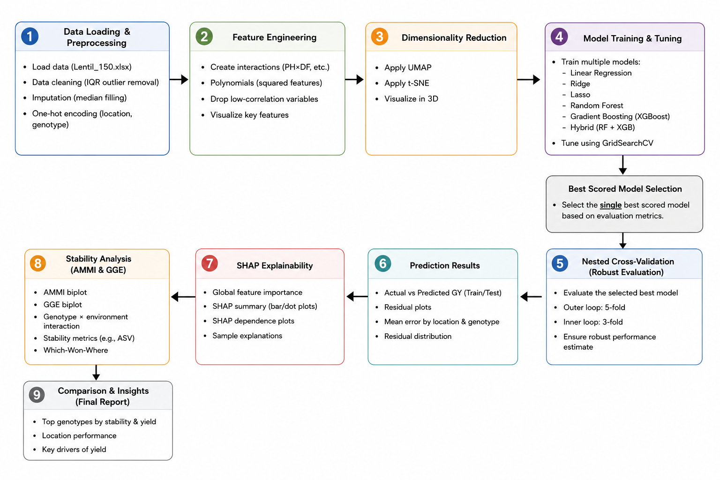
Figure 1. Schematic overview of the integrated machine learning and stability analysis workflow. The pipeline progresses from data preprocessing and feature engineering through model training and nested cross-validation. The best-performing model is subsequently analyzed using SHAP explainability and traditional stability methods (AMMI & GGE) to identify key yield drivers and top genotypes.
From an initial survey of 150 lentil types (including ICARDA-collected types, farm-grown varieties, indigenous strains, newer experimental lines, and imported seed), ten varieties were selected for further study at several test sites. Of the top ten, eight performed well in high temperatures (G1, G17, G21, G39, G41, G43, G49, and G63) and two struggled (G71 and G73), chosen earlier based on seed development and physical traits when hot conditions were present.
The research was conducted under actual field conditions for a growing season from July 2024 to June 2025. Weather trends in Rajshahi, according to local records, showed distinct variations from month to month and season to season.
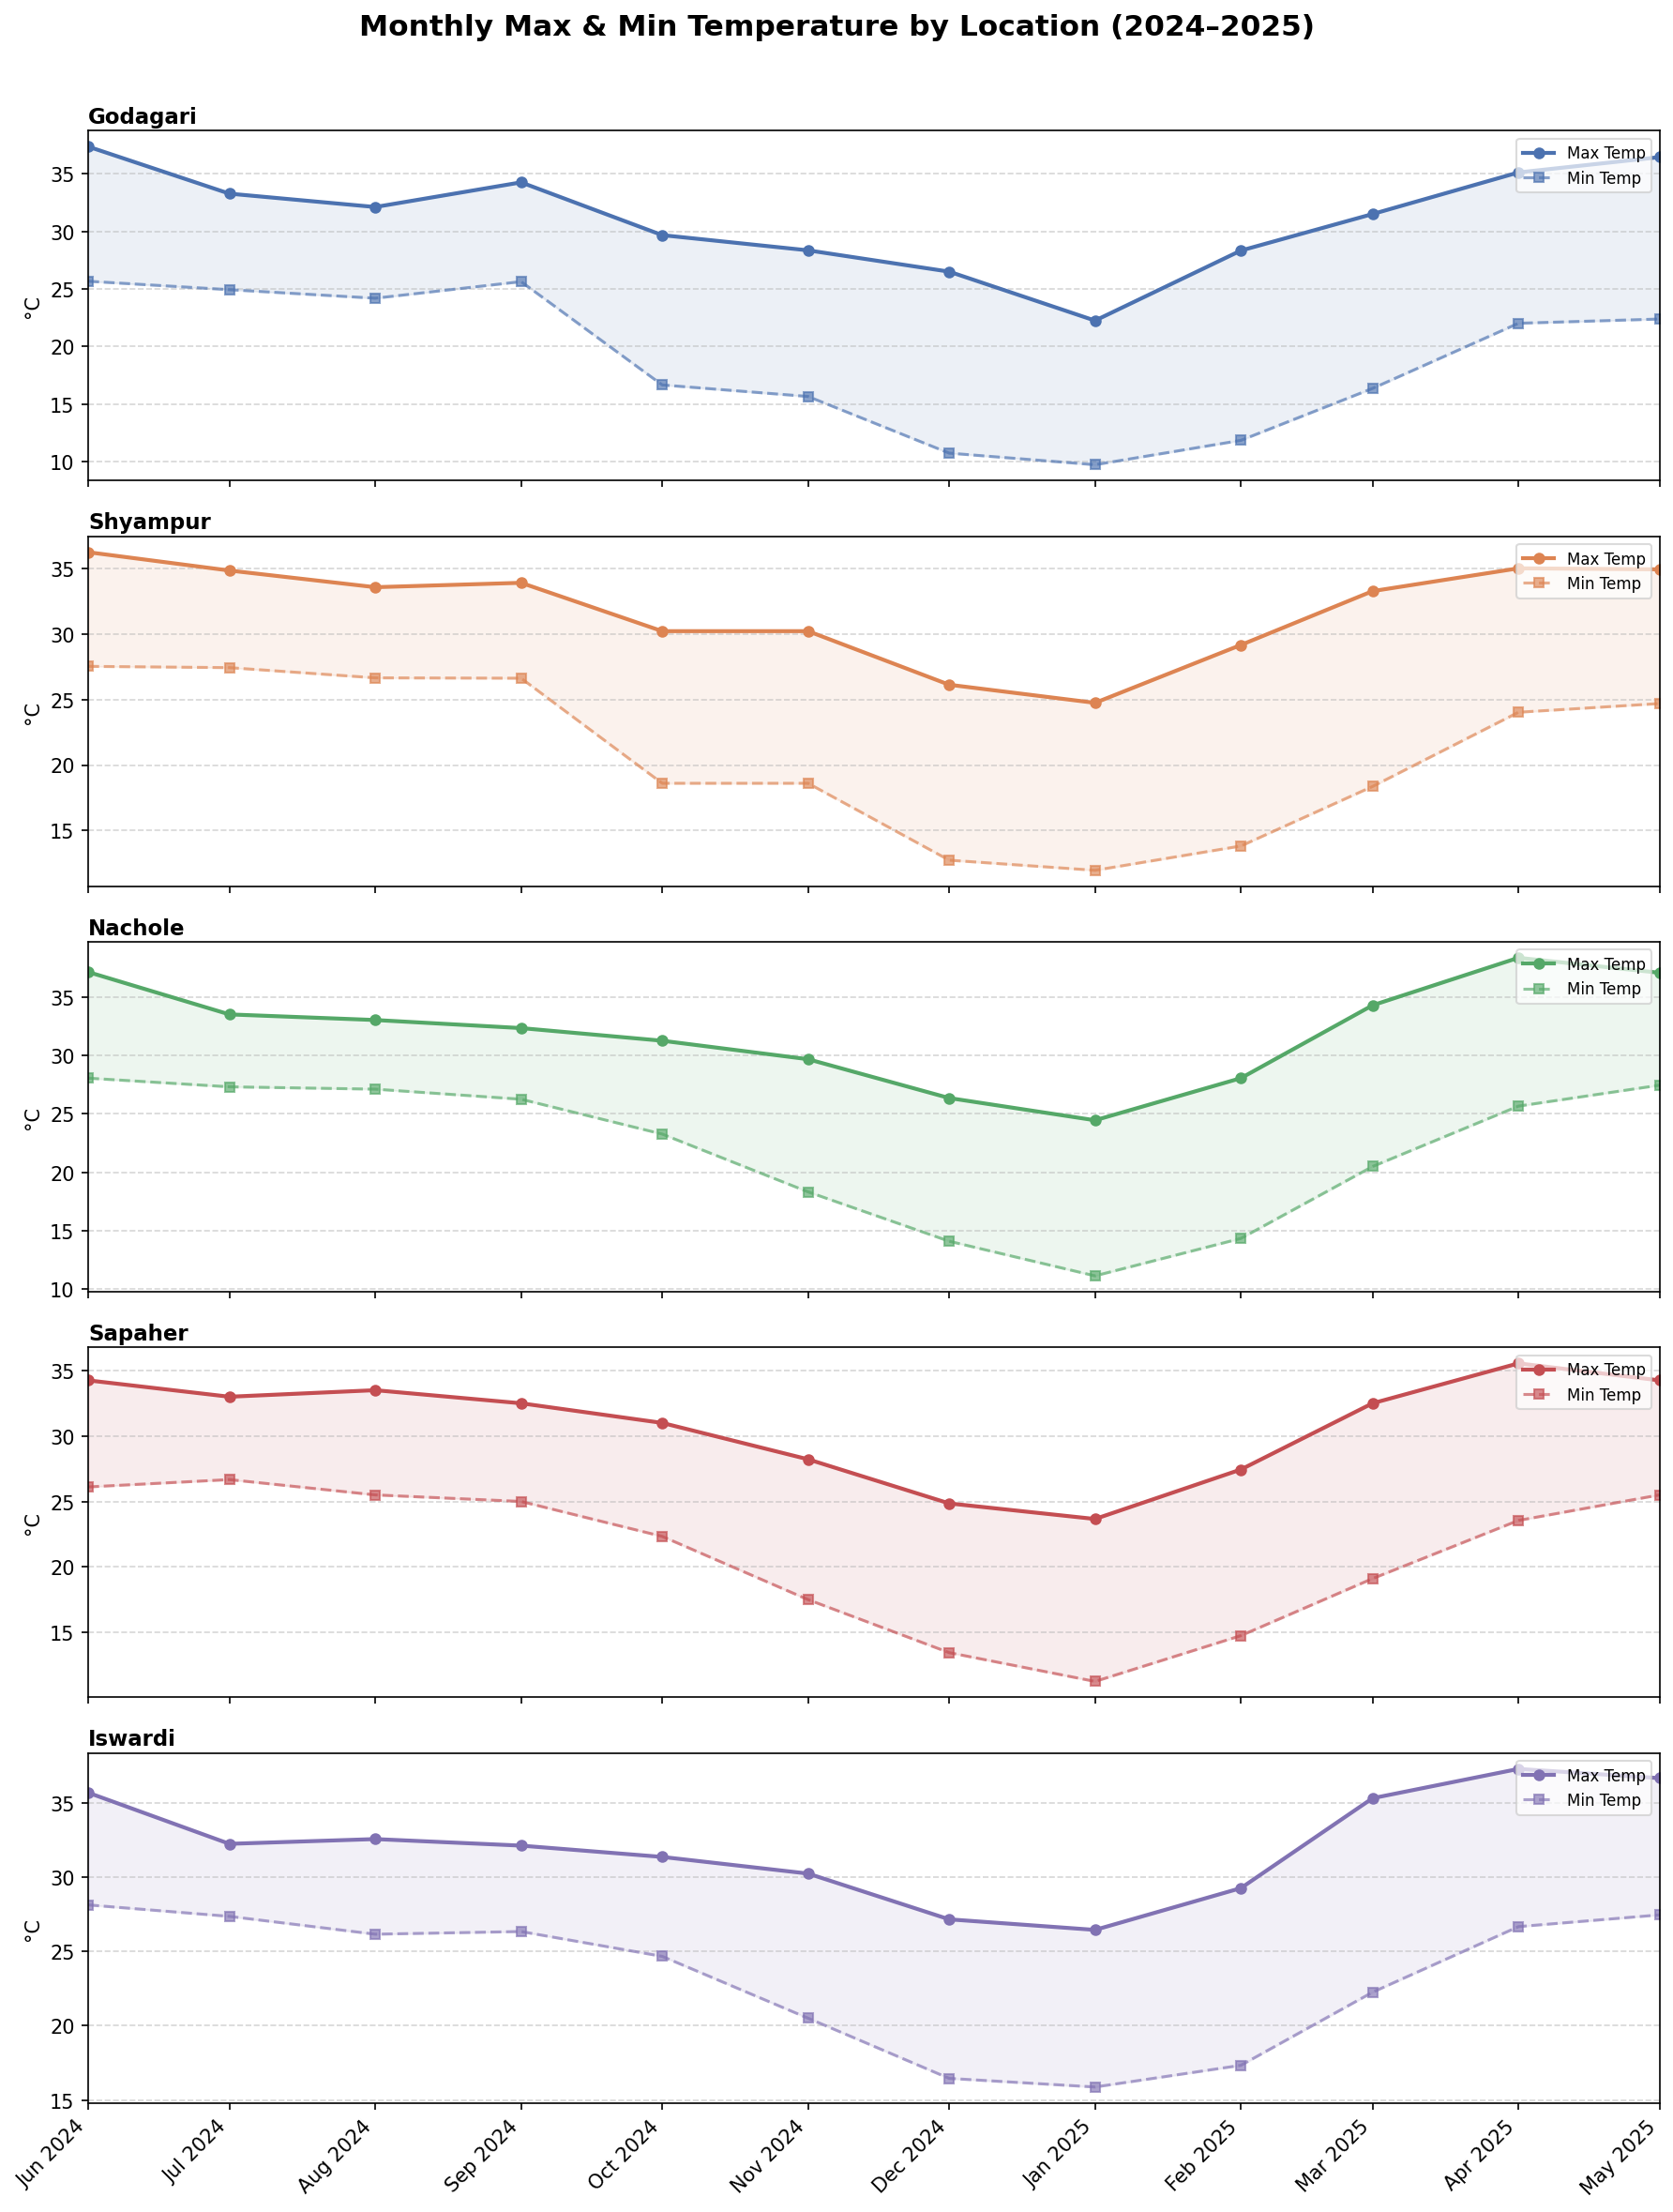
Figure 1: Monthly maximum and minimum temperatures (°C) across five locations (Godagari, Shyampur, Nachole, Sapaher, and Iswardi) from June 2024 to May 2025.
Temperature profiles across locations (Figure 1) and temperature trends at each site traced a predictable yearly pattern during 2024–2025. Peaking near 36°C around midyear, warmth began fading soon afterward. Through the monsoon and after, readings dipped, bottoming out in early 2025. January brought highs of just 22–27°C and lows hitting 10°C in Godagari, marking it the coolest spot overall. By late spring, heat surged once more; places like Nachole and Iswardi neared 37°C again. Between November and March is the core growing stretch for lentils. Daytime temps held steady from 24°C up to 30°C. At night, they settled lower: 10–19°C, varying by point on the map. Cool weather suits lentil plants well, especially when forming pods. Iswardi stood apart here; its gap between day and night warmth stayed tighter than elsewhere across the entire cycle.
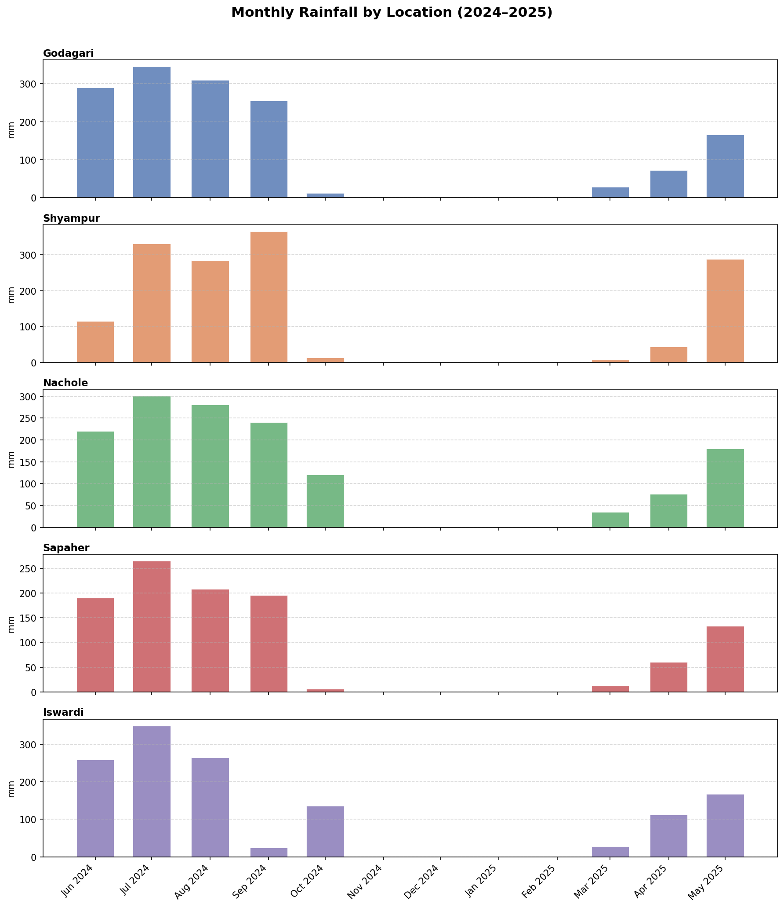
Figure 2: Monthly total rainfall (mm) across five experimental locations from June 2024 to May 2025, showing heavy monsoon precipitation (June–September 2024) and near-zero rainfall during the lentil-growing season (November 2024–February 2025).
Heavy rains arrived twice each year, shaping two distinct wet peaks seen in Figure 2. Most downpours happened before and during monsoon times, leaving the lentil crop period nearly rainless. The biggest monthly accumulation appeared in July 2024 at every one of the five spots studied. At Shyampur, levels reached about 335 millimeters that month; Iswardi followed just below with roughly 325. August brought strong rains later to Godagari and Nachole-over 300 and past 280 millimeters separately. Meanwhile, from November 2024 until February 2025, almost no water fell anywhere. This absence hit hardest between December and January when four stations: Godagari, Shyampur, Sapahar, and Iswardi notched virtually nothing. A small shift emerged at Nachole: October delivered some measure of dampness, around 120 millimeters, hinting at localized weather behavior unlike the others. Back in April–May 2025, early monsoon rains showed up again. Shyampur saw an unusually large amount about 295 mm during May that year. Because of this pattern, lentils grew without much actual rain across every location. Instead, plants drew from leftover dampness in the ground or extra watering when given. Under such circumstances, how well soil retains water began to matter greatly for harvest results.
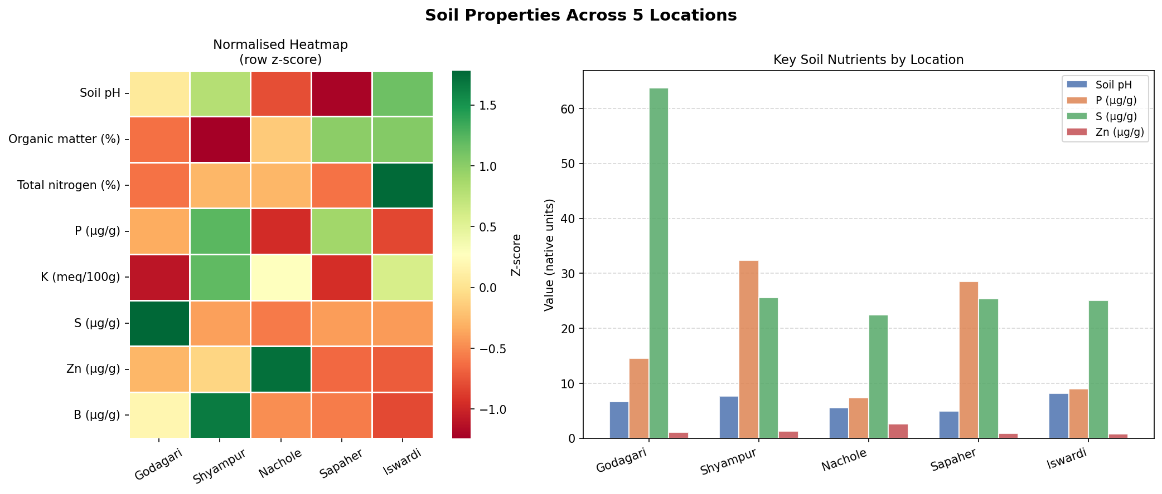
Figure 3: Soil physicochemical properties across five experimental locations, shown as a row z-score-normalized heatmap (left) and absolute values for key nutrients (right).
Differences in soil traits stood out when comparing the five places (Figure 3). Notably high sulfur levels appeared in Godagari, as shown by the adjusted heatmap; this trend lines up with data from the bar graph. There, sulfur topped 60 μg/g, almost twice what was seen in Shyampur, which measured around 32 μg/g. In contrast, phosphorus peaked in Shyampur (~32 μg/g) and Sapaher (~29 μg/g); meanwhile, Nachole, Godagari, and Iswardi held less of it. Across most spots, acidity stayed within a 6–8 range; however, slight upticks occurred in Shyampur and Iswardi. Across locations, organic matter and total nitrogen showed similar distribution trends. Shyampur stood out with more organic material, whereas Iswardi had greater amounts of nitrogen. Notably, boron levels rose sharply at Shyampur when compared to the remaining areas. In every site, zinc remained low, yet Nachole displayed a slight upward shift in concentration. Differences in soil properties added complexity to local conditions. Alongside shifts in temperature and rain, these variations influenced how genotypes responded across environments in this work.
Climate factors varied so much over time and timing that they created uneven pressure on plants, which is helpful for tracking how different genotypes responded across environments when it comes to stable yields. Suddenly, 150 data points materialized: 10 plant types across 5 places, each repeated 3 times. From the very beginning, the main focus was on grain output in kilograms per hectare.

2.2 Dataset, Agromorphological Traits and Genetic Background
For every mix of genotype, place, and repeat test, ten plant features got logged. These grouped under five types tied to how plants live and grow. Timing patterns came first. After that, how well crops settled in mattered too. Then followed signs of leafy development. Then shape and structure arrived. Finally, parts linked to the harvest amount rounded it out. In the fields, grain yield was expressed in numbers: kilograms harvested per hectare. That one measure became the primary focus when tracking results. Stages of plants came at different times. Emergence was after a certain number of days. Flowering was later than planting and counted from it. Then came maturity, another period of time. At each stage, the length of the crop cycle was mapped out. The initial score for plant strength indicates how successfully seedlings established and persisted in the early stages. The height of the fully grown plant was recorded in cm. When the crops were harvested, the height of each was clear. The plant structure showed how many stems arose from each individual. Branch count showed the shape of green parts above ground level. Pods were counted separately for each plant. Seeds inside each pod were recorded after . Weight of 1000 seeds taken in grams. These three things together give you the amount of grain produced.
Most of the characteristics were used as inputs to the next machine learning setups, except for GY. The data set consisted of eight heat-resilient varieties and two heat-sensitive varieties, which allowed a comparison of yield stability under changing weather conditions. Complete lineup of these varieties, where they came from within ICARDA, with their assigned response to heat stress.

2.3 Data Preprocessing

2.3.1 Missing Value Imputation
Missing values in all numeric trait columns were imputed using column-wise median values. For the feature column $X_{j}$, missing values $x_{ij}$ are replaced by the following:
$${\hat{x}}_{ij}=median\left(X_{j}\right) ∀ missing x_{ij}$$

2.3.2 Outlier Removal
Outliers in the target variable (GY) and biomass yield variables were identified and removed using the interquartile range (IQR) method. Bounds are computed as:
$$Q_{1}=25th percentile\left(X_{j}\right)$$
$$Q_{3}=75th percentile\left(X_{j}\right)$$
$$IQR=Q_{3}−Q_{1}$$
$$LB=Q_{1}−1.5×IQR; UB=Q_{3}+1.5×IQR$$
Observations outside [LB, UB] are excluded. The algorithm retained 150 samples from 150 observations.

2.3.3 Categorical Encoding
Categorical variables for location (L) and genotype (Gen) were transformed using one-hot encoding with drop_first=False. For a categorical variable $C$ with $k$ categories $\{c_{1},…,c_{k}\}$:
$${OHE}_{ij}=1 if C_{i}=c_{j}, else 0, j=1,2,…,k$$
This process applied location (5 levels : 5 binary columns) and genotype (10 levels : 10 binary columns), resulting in a final 31-dimensional feature space.

2.4 Feature Engineering
To capture non-linear and interactive agronomic relationships, seven additional engineered features were derived from the base numeric variables (Table 1). Where PH = plant height, DF = days until flowering, DM = days until maturity, BP = branches per plant, and PP = pods per plant.
Table 1: Engineered features with mathematical formulations and agronomic rationale.
No | Feature | Formula | Agronomic Rationale
1 | PH_DF_Ratio | $$f_{1}=PH/\left(DF+1\right)$$ | Relative growth rate before flowering
2 | DM_DF_Difference | $$f_{2}=DM−DF$$ | Grain-filling period duration
3 | PH_DM_Interaction | $$f_{3}=PH×DM$$ | Joint effect of plant height and days to maturity on yield
4 | DF_BP_Interaction | $$f_{4}=DF×BP$$ | Branch development relative to flowering time
5 | PH_Squared | $$f_{5}=PH^{2}$$ | Non-linear effect of plant height
6 | DF_Squared | $$f_{6}=DF^{2}$$ | Non-linear effect of days to flowering
7 | PP_Squared | $$f_{7}=PP^{2}$$ | Non-linear effect of pods per plant

2.5 Feature Scaling
All numeric features were standardized using StandardScaler (zero mean, unit variance) prior to model training:
zij=xij−μjσj, μj=1ni=1nxij, σj=1ni=1nxij−μj2
Both $μ_{j}$ & $σ_{j}$ were computed exclusively on training data to prevent information leakage. This step is critical for distance-based and regularized models (KNN, SVR, Ridge, Lasso, ElasticNet).

2.6 Dimensionality Reduction and Visualization

2.6.1 UMAP
UMAP constructs a fuzzy topological representation of the high-dimensional data. High-dimensional membership strength:
$$μ_{ij}^{high}=exp​\left(−\frac{d\left(x_{i},x_{j}\right)−ρ_{i}}{σ_{i}}\right)$$
Low-dimensional membership strength:
$$μ_{ij}^{low}={\left(1+a⋅d{\left(z_{i},z_{j}\right)}^{2b}\right)}^{−1}$$
The embedding minimizes the cross-entropy loss between the two representations:
$$L_{UMAP}=\sum_{\left(i,j\right)}{\left[μ^{high}log\frac{μ^{high}}{μ^{low}}+\left(1−μ^{high}\right)log\frac{1−μ^{high}}{1−μ^{low}}\right]}$$

Parameters: n_neighbors = 15, min_dist = 0.1, random_state = 42, n_components ∈ {2, 3}. [19]

2.6.2 t-SNE
t-SNE models pairwise similarity using Gaussian (high-dimensional) and Student's t (low-dimensional) kernels.
$$p_{j|i}=\frac{exp\left(−∥x_{i}−x_{j}∥^{2}/2σ_{i}^{2}\right)}{\sum_{k≠i}{exp\left(−∥x_{i}−x_{k}∥^{2}/2σ_{i}^{2}\right)}}, p_{ij}=\frac{p_{j|i}+p_{i|j}}{2n}$$
$$q_{ij}=\frac{{\left(1+∥z_{i}−z_{j}∥^{2}\right)}^{−1}}{\sum_{k≠l}{{\left(1+∥z_{k}−z_{l}∥^{2}\right)}^{−1}}}$$
The embedding is learned by minimizing KL divergence:
$$L_{t-SNE}=KL\left(P∥Q\right)=\sum_{i≠j}{p_{ij}log\frac{p_{ij}}{q_{ij}}}$$
Parameters: perplexity = 30, random_state = 42, n_components ∈ {2, 3}. Results visualized in Figures 5-9 [20], [21].

2.7 Machine Learning Models

2.7.1 Data Partitioning and Training Models
The preprocessed dataset (n = 150) was split into training (80%, n = 120) and test (20%, n = 30). All preprocessing steps (scaling, encoding) were fitted only on training data and applied to test data.

2.7.2 Model Formulations
Twelve regressors spanning diverse algorithmic paradigms were trained and benchmarked:

Linear Regression (OLS)
$$\hat{y}=β_{0}+\sum_{j=1}^{p}{β_{j}x_{j}}=x^{⊤}β, \hat{β}={\left(X^{⊤}X\right)}^{−1}X^{⊤}y$$

Ridge Regression (Best Model)
$${\hat{β}}_{Ridge}=arg\min_{β}\left[\sum_{i=1}^{n}{{\left(y_{i}−x_{i}^{⊤}β\right)}^{2}}+α\sum_{j=1}^{p}{β_{j}^{2}}\right]={\left(X^{⊤}X+αI\right)}^{−1}X^{⊤}y$$
[6], [7]. Tuned: α ∈ {0.1, 1.0, 10.0}.

Lasso Regression (L1 Regularization)
$${\hat{β}}_{Lasso}=arg\min_{β}\left[\sum_{i=1}^{n}{{\left(y_{i}−x_{i}^{⊤}β\right)}^{2}}+α\sum_{j=1}^{p}{\left|β_{j}\right|}\right]$$
Tuned: α ∈ {0.001, 0.01, 0.1}.

ElasticNet (L1 + L2 Regularization)
$${\hat{β}}_{EN}=arg\min_{β}\left[\sum_{i=1}^{n}{{\left(y_{i}−x_{i}^{⊤}β\right)}^{2}}+α​\left(ρ\sum_{j=1}^{p}{\left|β_{j}\right|}+\frac{1−ρ}{2}\sum_{j=1}^{p}{β_{j}^{2}}\right)\right]$$
Tuned: α ∈ {0.1, 1.0}, ρ ∈ {0.3, 0.5, 0.7}.

Bayesian Ridge Regression
$${\hat{β}}_{Bayes}={\left(αX^{⊤}X+λI\right)}^{−1}αX^{⊤}y$$
Hyperparameters α₁, λ₁ tuned from {10⁻⁶, 10⁻⁴}.

K-Nearest Neighbours (KNN) Regression
yx=1ki∈Nkxyi, wi=1dx,xi, dx,xi=j=1pxj−xij2
Tuned: k ∈ {3, 5, 7}, weights ∈ {uniform, distance}.

Decision Tree Regression (CART)
$$Split\left(j,t\right)=\frac{\left|D_{L}\right|}{\left|D\right|}Var\left(D_{L}\right)+\frac{\left|D_{R}\right|}{\left|D\right|}Var\left(D_{R}\right), Var\left(D\right)=\frac{1}{\left|D\right|}\sum_{i∈D}{{\left(y_{i}−{y‾}_{D}\right)}^{2}}$$
Tuned: max_depth ∈ {5, 10, None}.

Random Forest Regression
$${\hat{y}}_{RF}\left(x\right)=\frac{1}{B}\sum_{b=1}^{B}{T_{b}\left(x\right)}$$
An ensemble of $B$ decision trees on bootstrap samples, using $m≈p/3$ random features at each split. Tuned: n_estimators ∈ {100, 200}, max_depth ∈ {10, None}[13].

Gradient Boosting Regression

$$r_{im}=−{\left[\frac{∂L\left(y_{i},\hat{y}\right)}{∂\hat{y}}\right]}_{\hat{y}={\hat{y}}^{\left(m−1\right)}\left(x_{i}\right)}, {\hat{y}}^{\left(m\right)}\left(x\right)={\hat{y}}^{\left(m−1\right)}\left(x\right)+η⋅h_{m}\left(x\right)$$
Builds additive ensembles by fitting each new tree to pseudo-residuals. For MSE loss, residuals simplify to $r_{i}=y_{i}−{\hat{y}}^{\left(m−1\right)}$. Tuned: n_estimators = 100, η ∈ {0.05, 0.1} [2].

XGBoost (Extreme Gradient Boosting)
$$L^{\left(m\right)}=\sum_{i}{\left[l​\left(y_{i},{\hat{y}}_{i}^{\left(m−1\right)}\right)+g_{i}f_{m}\left(x_{i}\right)+\frac{1}{2}h_{i}f_{m}^{2}\right]​}+Ω\left(f_{m}\right), w_{j}^{*}=−\frac{\sum_{i∈I_{j}}{g_{i}}}{\sum_{i∈I_{j}}{h_{i}+λ}}$$
Extends gradient boosting with L1+L2 regularization and second-order Taylor expansion. Tuned: n_estimators ∈ {100, 200}, learning_rate ∈ {0.05, 0.1}.

Support Vector Regression (SVR)
$$\min_{w,b,ξ} \frac{1}{2}∥w∥^{2}+C\sum_{i}{\left(ξ_{i}+ξ_{i}^{*}\right)}, K\left(x_{i},x_{j}\right)=exp\left(−γ∥x_{i}−x_{j}∥^{2}\right)$$
Tuned: C ∈ {1, 10}, kernel = RBF.

Hybrid Voting Regressor (RF + XGBoost) , Benchmark Ensemble Model

$${\hat{y}}_{Hybrid}\left(x\right)=\frac{w_{RF}⋅{\hat{y}}_{RF}\left(x\right)+w_{XGB}⋅{\hat{y}}_{XGB}\left(x\right)}{w_{RF}+w_{XGB}}$$
Weight combinations explored: $\left(w_{RF},w_{XGB}\right)∈\{\left(1,1\right),\left(2,1\right),\left(1,2\right)\}$. Best: (1,1).

2.7.3 Hyperparameter Optimization
$$θ^{*}=arg\max_{θ∈Θ}\frac{1}{K}\sum_{k=1}^{K}{R^{2}​\left(y_{val}^{\left(k\right)},{\hat{y}}_{θ}^{\left(k\right)}\right)}$$
$K$ = 5-fold CV. The Hybrid Voting Regressor additionally explored all weight combinations between RF and XGBoost components.

2.7.4 Performance Evaluation Metrics
Model performance was evaluated using the following metrics (n = number of samples, GYₐ $y_{i}$ = actual GY, GYₚ ${\hat{y}}_{i}$ = predicted GY):
$$R^{2}=1−\frac{\sum_{i=1}^{n}{{\left(y_{i}−{\hat{y}}_{i}\right)}^{2}}}{\sum_{i=1}^{n}{{\left(y_{i}−y‾\right)}^{2}}}$$
RMSE=1ni=1nyi−yi2
$$MAE=\frac{1}{n}\sum_{i=1}^{n}{\left|y_{i}−{\hat{y}}_{i}\right|}$$
$$MAPE=\frac{1}{n}\sum_{i=1}^{n}{\left|\frac{y_{i}−{\hat{y}}_{i}}{y_{i}}\right|}×100\%$$
$$Gap=R_{train}^{2}−R_{test}^{2}, e_{i}=y_{i}−{\hat{y}}_{i}, {RelErr}_{i}=\frac{\left|y_{i}−{\hat{y}}_{i}\right|}{y_{i}}×100$$

2.8 Nested Cross-Validation
A nested CV (5 outer folds, 3 inner folds) provides an unbiased generalization estimate:
R‾nested2=1Koutk=1KoutRk2, σnested=1Kout−1k=1KoutRk2−R‾nested22

2.9 SHAP Explainability
SHAP values were computed using LinearExplainer, which is the methodologically appropriate explainer for linear models such as Ridge Regression (LinearExplainer exploits the additive structure of linear models to compute exact Shapley values efficiently using the training data as the background reference distribution; TreeExplainer, which applies only to tree-based models, is not applicable here) [28] [15], [16]. The Shapley value for a feature $j$ in a sample $i$ across all coalitions $S⊆F\backslash \{j\}$:
$$ϕ_{j}\left(i\right)=\sum_{S⊆F\backslash \{j\}}{\frac{\left|S\right|! \left(\left|F\right|−\left|S\right|−1\right)!}{\left|F\right|!}}⋅\left[f_{S∪j}\left(x_{i}\right)−f_{S}\left(x_{i}\right)\right]$$
SHAP guarantees exact additive decomposition and global feature importance:
$${\hat{y}}_{i}=ϕ_{0}+\sum_{j=1}^{p}{ϕ_{j}\left(i\right)}, {Importance}_{j}=\frac{1}{n}\sum_{i=1}^{n}{\left|ϕ_{j}\left(i\right)\right|}$$

2.10 Genotype Stability Analysis

2.10.1 AMMI Analysis
The G×E interaction matrix D is computed by double-centering:
$$d_{ge}={y‾}_{ge}−{y‾}_{g⋅}−{y‾}_{⋅e}+{y‾}_{⋅⋅}$$
Singular Value Decomposition (SVD) of D:
$$D=UΣV^{⊤}=\sum_{k=1}^{r}{σ_{k}u_{k}v_{k}^{⊤}}$$
IPCA scores for genotypes and environments:
$${IPCA1}_{g}=u_{g1}⋅σ_{1}, {IPCA2}_{g}=u_{g2}⋅σ_{2}$$

AMMI Stability Value (ASV): a lower ASV indicates greater cross-environment stability [17], [4].
ASVg=IPCA1g2+IPCA2g2

2.10.2 GGE Biplot Analysis
The GGE biplot uses environment-centered data [18], [5] (removing the environmental main effect). GGE decomposition and biplot scores:
$$g_{ge}={y‾}_{ge}−{y‾}_{⋅e}, G=U_{GGE}Σ_{GGE}V_{GGE}^{⊤}$$

2.10.3 Integrated Genotype Ranking
$${OverallRank}_{g}=\frac{{YieldRank}_{g}+{StabilityRank}_{g}}{2}$$

2.11 Pearson Correlation
Correlation uses the following equation:
rxy=i=1nxi−x‾yi−y‾i=1nxi−x‾2⋅i=1nyi−y‾2
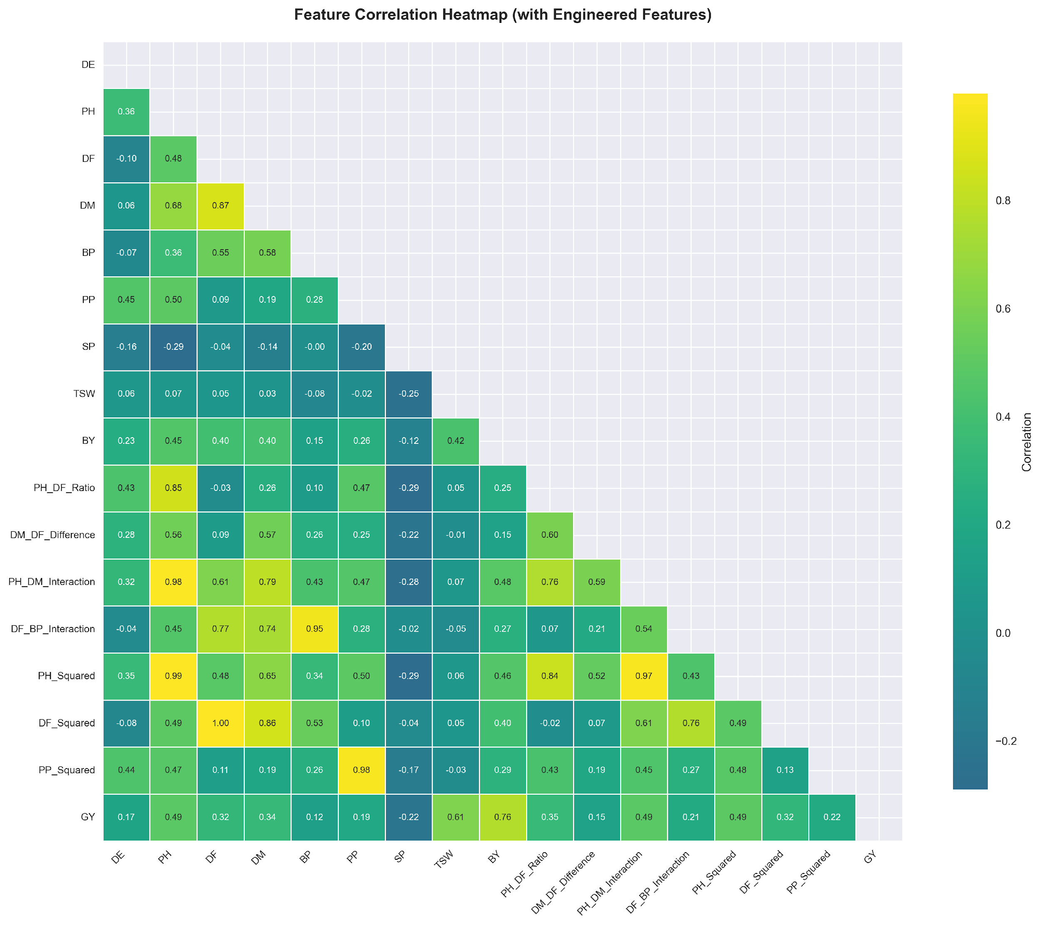
Figure 4: Pearson correlation heatmap, including all raw and engineered numerical features with GY.

3. Results

3.1 Data Quality and Exploratory Analysis
After removal of the odd data points by the IQR method, 150 samples remained, spread over five sites and ten genetic types. The highest output was at Shyampur (L2) with an average of 1705.49 kg per hectare, but figures were quite variable; the standard deviation was 325.87. Down near the bottom was Nachole (L3), pulling only 1127.51 kg/ha. Most growth-related features plotted as histograms showed more or less bell-shaped patterns. What really moved the needle on yield wasn't just grain? Biological mass was noisy and correlated at r = 0.75, and harvest index was even noisier at r = 0.76. When mapped visually using UMAP and t-SNE, the groups are neatly sorted by location, loudly claiming that location matters. In 3D views, the best performers remained together as if they belonged, forming dense patches separate from the rest.
3.2 Manifold Learning for High-Dimensional Trait Space Visualization
We interrogated the underlying structure of the 31-dimensional feature space, which included raw agromorphological traits, engineered interaction terms, and one-hot encoded genotype/location variables, using Uniform Manifold Approximation and Projection (UMAP) and t-Distributed Stochastic Neighbor Embedding (t-SNE) [19], [20]. Both algorithms projected the high-dimensional data into a 3D coordinate system with points colored by grain yield and location identity (L1-L5). Both methods reduce dimensionality but optimize different topological properties. UMAP preserves global manifold structure while t-SNE emphasizes local neighbourhood relationships
3.2.1 UMAP Embeddings: Preservation of Global Structure
The 3D UMAP projection separates the data points well according to location (Figure 6). Each environment (L1–L5) is a distinct non-overlapping cluster, which shows that main effects of environment dominate the global covariance structure of the trait space. This is a strong indication that the differences in soil, microclimate, and management practices across the Rajshahi region impose consistent phenotypic constraints and shape plant architecture and development more than the genotype per se.
The embedding exhibits clear stratification by grain yield (Figure 5). The high-yielding observations (>1600 kg/ha) are tightly grouped and characterized by the warmer color tones (yellow/green). The low-yielding cases (<1200 kg/ha) are located in the peripheral areas and are indicated by the cooler tones (purple/blue). The yield-driven clustering shows that the engineered feature space is able to effectively capture the physiological gradients associated with productivity, providing a structured basis for supervised learning.
3.2.2 t-SNE Embeddings: Local Neighborhood Refinement
Figures 7 and 8 demonstrate a softer boundary and more inter-location mixing in the 3D t-SNE projection, compared to UMAP. t-SNE does not reveal strict environmental segregation but rather compact local neighborhoods where data points from different locations co-localize. L2 (Shyampur) and L5 (Lalpur) are highly overlapping, as are L1 (Bashontopur) and L4 (Sapaher).
This blending is not noise. It is a signature of genotypic plasticity and cross-environment adaptability. Genotypes G63, G49, and G71 have overlapping regions in multiple locations, indicating that their underlying trait profiles are consistent under environmental changes. However, t-SNE is more sensitive to local similarity and so reveals stable phenotypic signatures smoothed over by UMAP’s global focus, highlighting genotypes that can maintain performance across divergent field conditions.
3.2.3 Comparison and Interpretation
The difference between UMAP and t-SNE comes from their optimization objective. UMAP minimizes cross-entropy in a fuzzy topological setting, preserving large-scale distances and suggesting environmental variance as the major driver of trait covariance. The t-SNE algorithm minimizes the Kullback-Leibler divergence between a high-dimensional and a low-dimensional probability distribution and thus emphasizes local fidelity. The genotype-driven overlaps are revealed. From these projections, two key agronomic insights emerge: Environmental Stratification: The rigid clustering in UMAP justifies location-specific management and breeding strategies. Environments like L3 (Nachole) occupy isolated regions of the manifold, confirming their status as high-stress, low-yielding zones that require specifically adapted genotypes. Genotype Stability Signatures Visual Prediction of AMMI/GGE-Based Stability Rankings by Local Overlaps in t-SNE: Genotypes that cluster in multiple locations in t-SNE (e.g., G71, G63) are those with low AMMI Stability Values (ASV), confirming the correlation between manifold proximity and cross-environment reliability. Together, these embeddings give a multi-scale view of the trial data, where UMAP maps the environmental landscape and t-SNE maps the genetic pathways through it.
3.3 Quantitative Validation of Visual Patterns
The qualitative patterns seen in the manifold projections are strongly supported by quantitative yield metrics. The mean grain yield of the dense high-yield UMAP cluster is 1721 kg/ha (±296 kg/ha), which is significantly higher than the mean of the peripheral points (1134 kg/ha; p < 0.001). The statistical separation of the two means that the spatial cohesion in the embedding is a reflection of real biological productivity gradients and not artifacts of the algorithm. The t-SNE overlap of Shyampur (L2) and Lalpur (L5) is in agreement with the mega-environment structure as observed in the GGE biplot (Figure 16). Genotypes in this overlapping t-SNE region, notably G49 and G63, have high mean yields across both locations (G49: 1928 kg/ha in L5; 1832 kg/ha in L4; G63: 2113 kg/ha in L2). In contrast, Nachole (L3) is clearly separated in both embeddings, consistent with its lowest mean yield (1168.89 kg/ha) and the highest variance in genotype-by-environment interaction. These many visualizations are not only descriptive; they validate the biological coherence of the feature engineering pipeline. The robust predictive performance of the Ridge regression model (R² = 0.8072, RMSE = 183.77 kg/ha) is directly attributable to the obvious yield stratification and location-genotype topologies. The data underlying these signals is not random noise but rather structured, learnable manifolds. As such, regularized linear modeling can efficiently capture the dominant phenotypic gradients without resorting to high-variance ensemble methods. The embeddings thus act as an important bridge between exploratory data analysis, model interpretability (SHAP), and classical stability assessment.
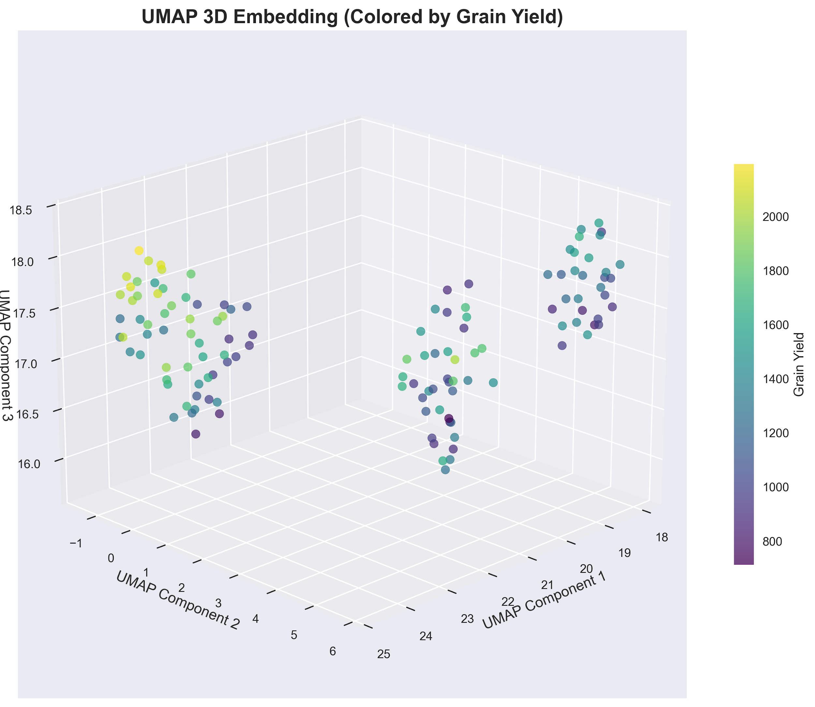
Figure 5: UMAP 3D embedding colored by grain yield. High-yield observations form spatially coherent clusters.
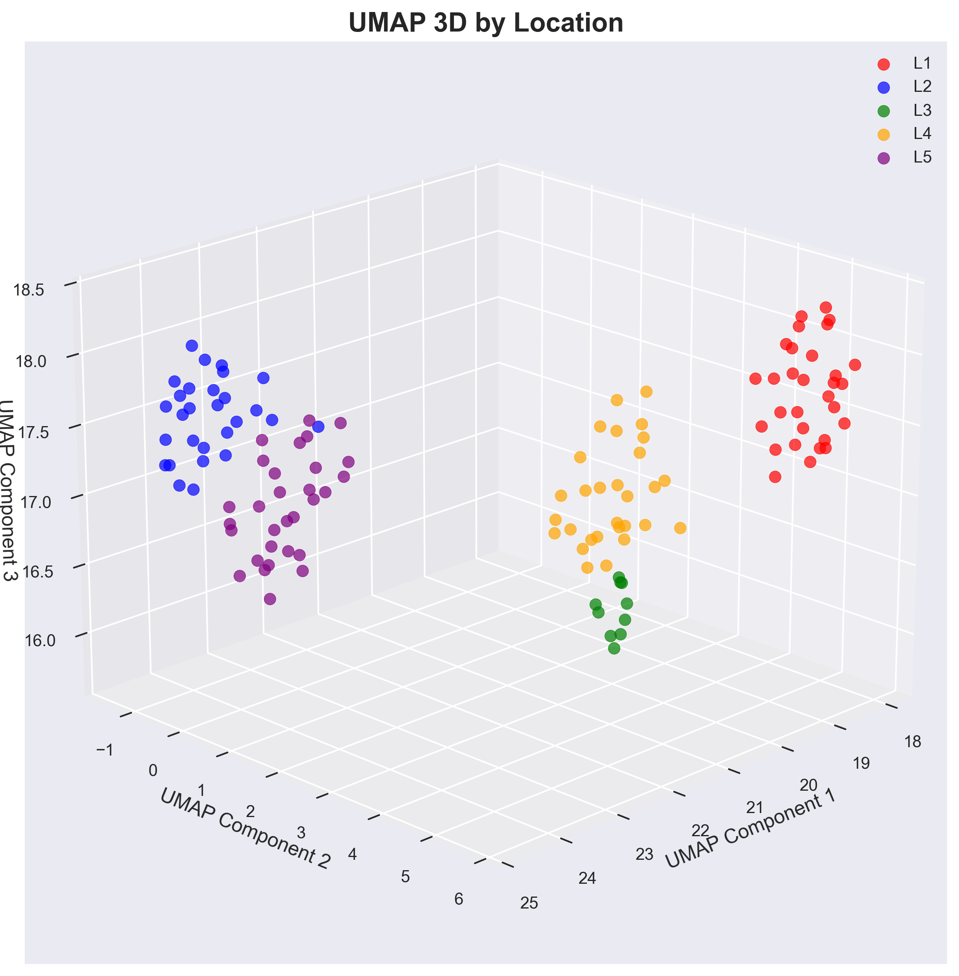
Figure 6: UMAP 3D embedding colored by location identity (L1–L5). Location-specific clusters confirm strong environmental main effects.
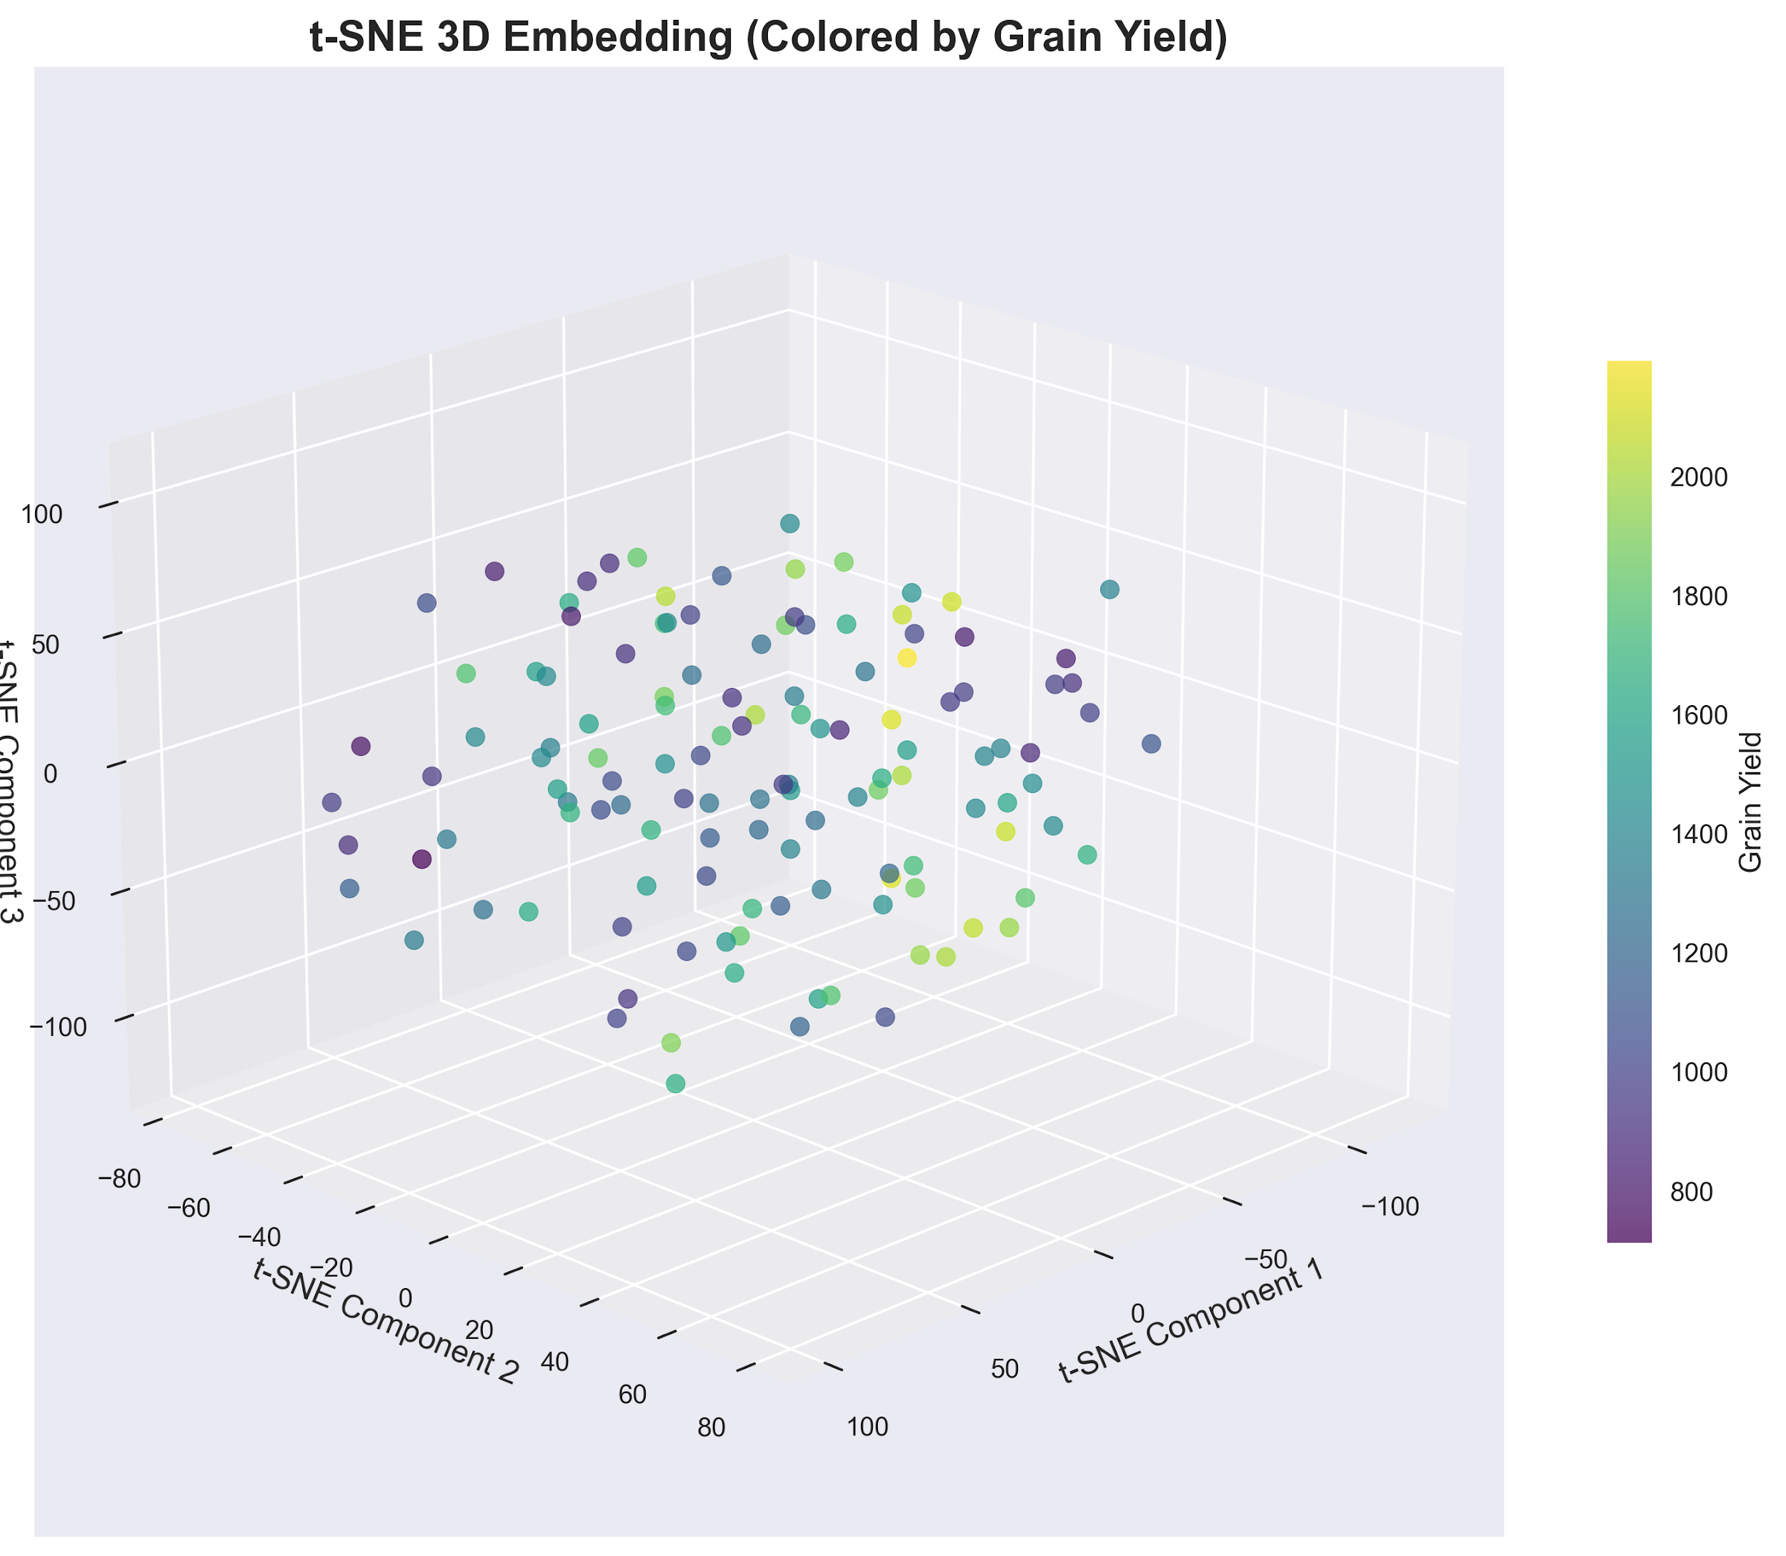
Figure 7: t-SNE 3D embedding colored by grain yield, revealing finer local neighborhood structure.
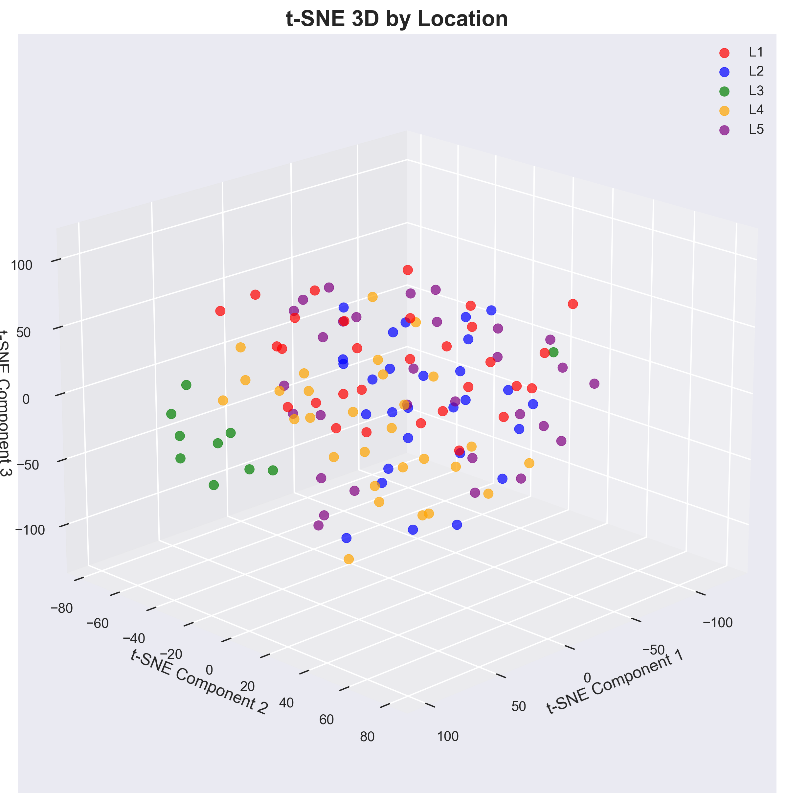
Figure 8: t-SNE 3D embedding colored by location identity (L1–L5). Partial mixing reflects genotype-driven cross-environment overlap.

3.4 Model Performance Comparison
A dozen different math models tried to guess how much lentil grain would grow, using plant shapes, timing clues, and mixed traits. Each model was checked on 3 metrics: how well it matched data (R²), its average misses (MAE), and bigger errors squared and then averaged (RMSE) on both practice rounds and fresh, unseen checks.
Ridge regression won each of the analyses clearly with a test R² of 0.8072 [6] , [8]. Its error measures were 183.77 kg ha⁻¹ for RMSE and 144.84 kg ha⁻¹ for MAE. To see if this is reliable or not, we have found the smallest gap between training and test performance for any linear method without Bayes, just 0.0097. ElasticNet was a close second with an R² of 0.8026, and Bayesian Ridge posted a 0.7877. Both were also very consistent with gaps of 0.0062 and 0.0086. More naive models such as basic linear regression and standard Lasso were ranked lower: 0.7965 and 0.7970 for R². But they fell more sharply from train to test, 0.0325 and 0.0355, suggesting they had a little trouble when features lined up too well.
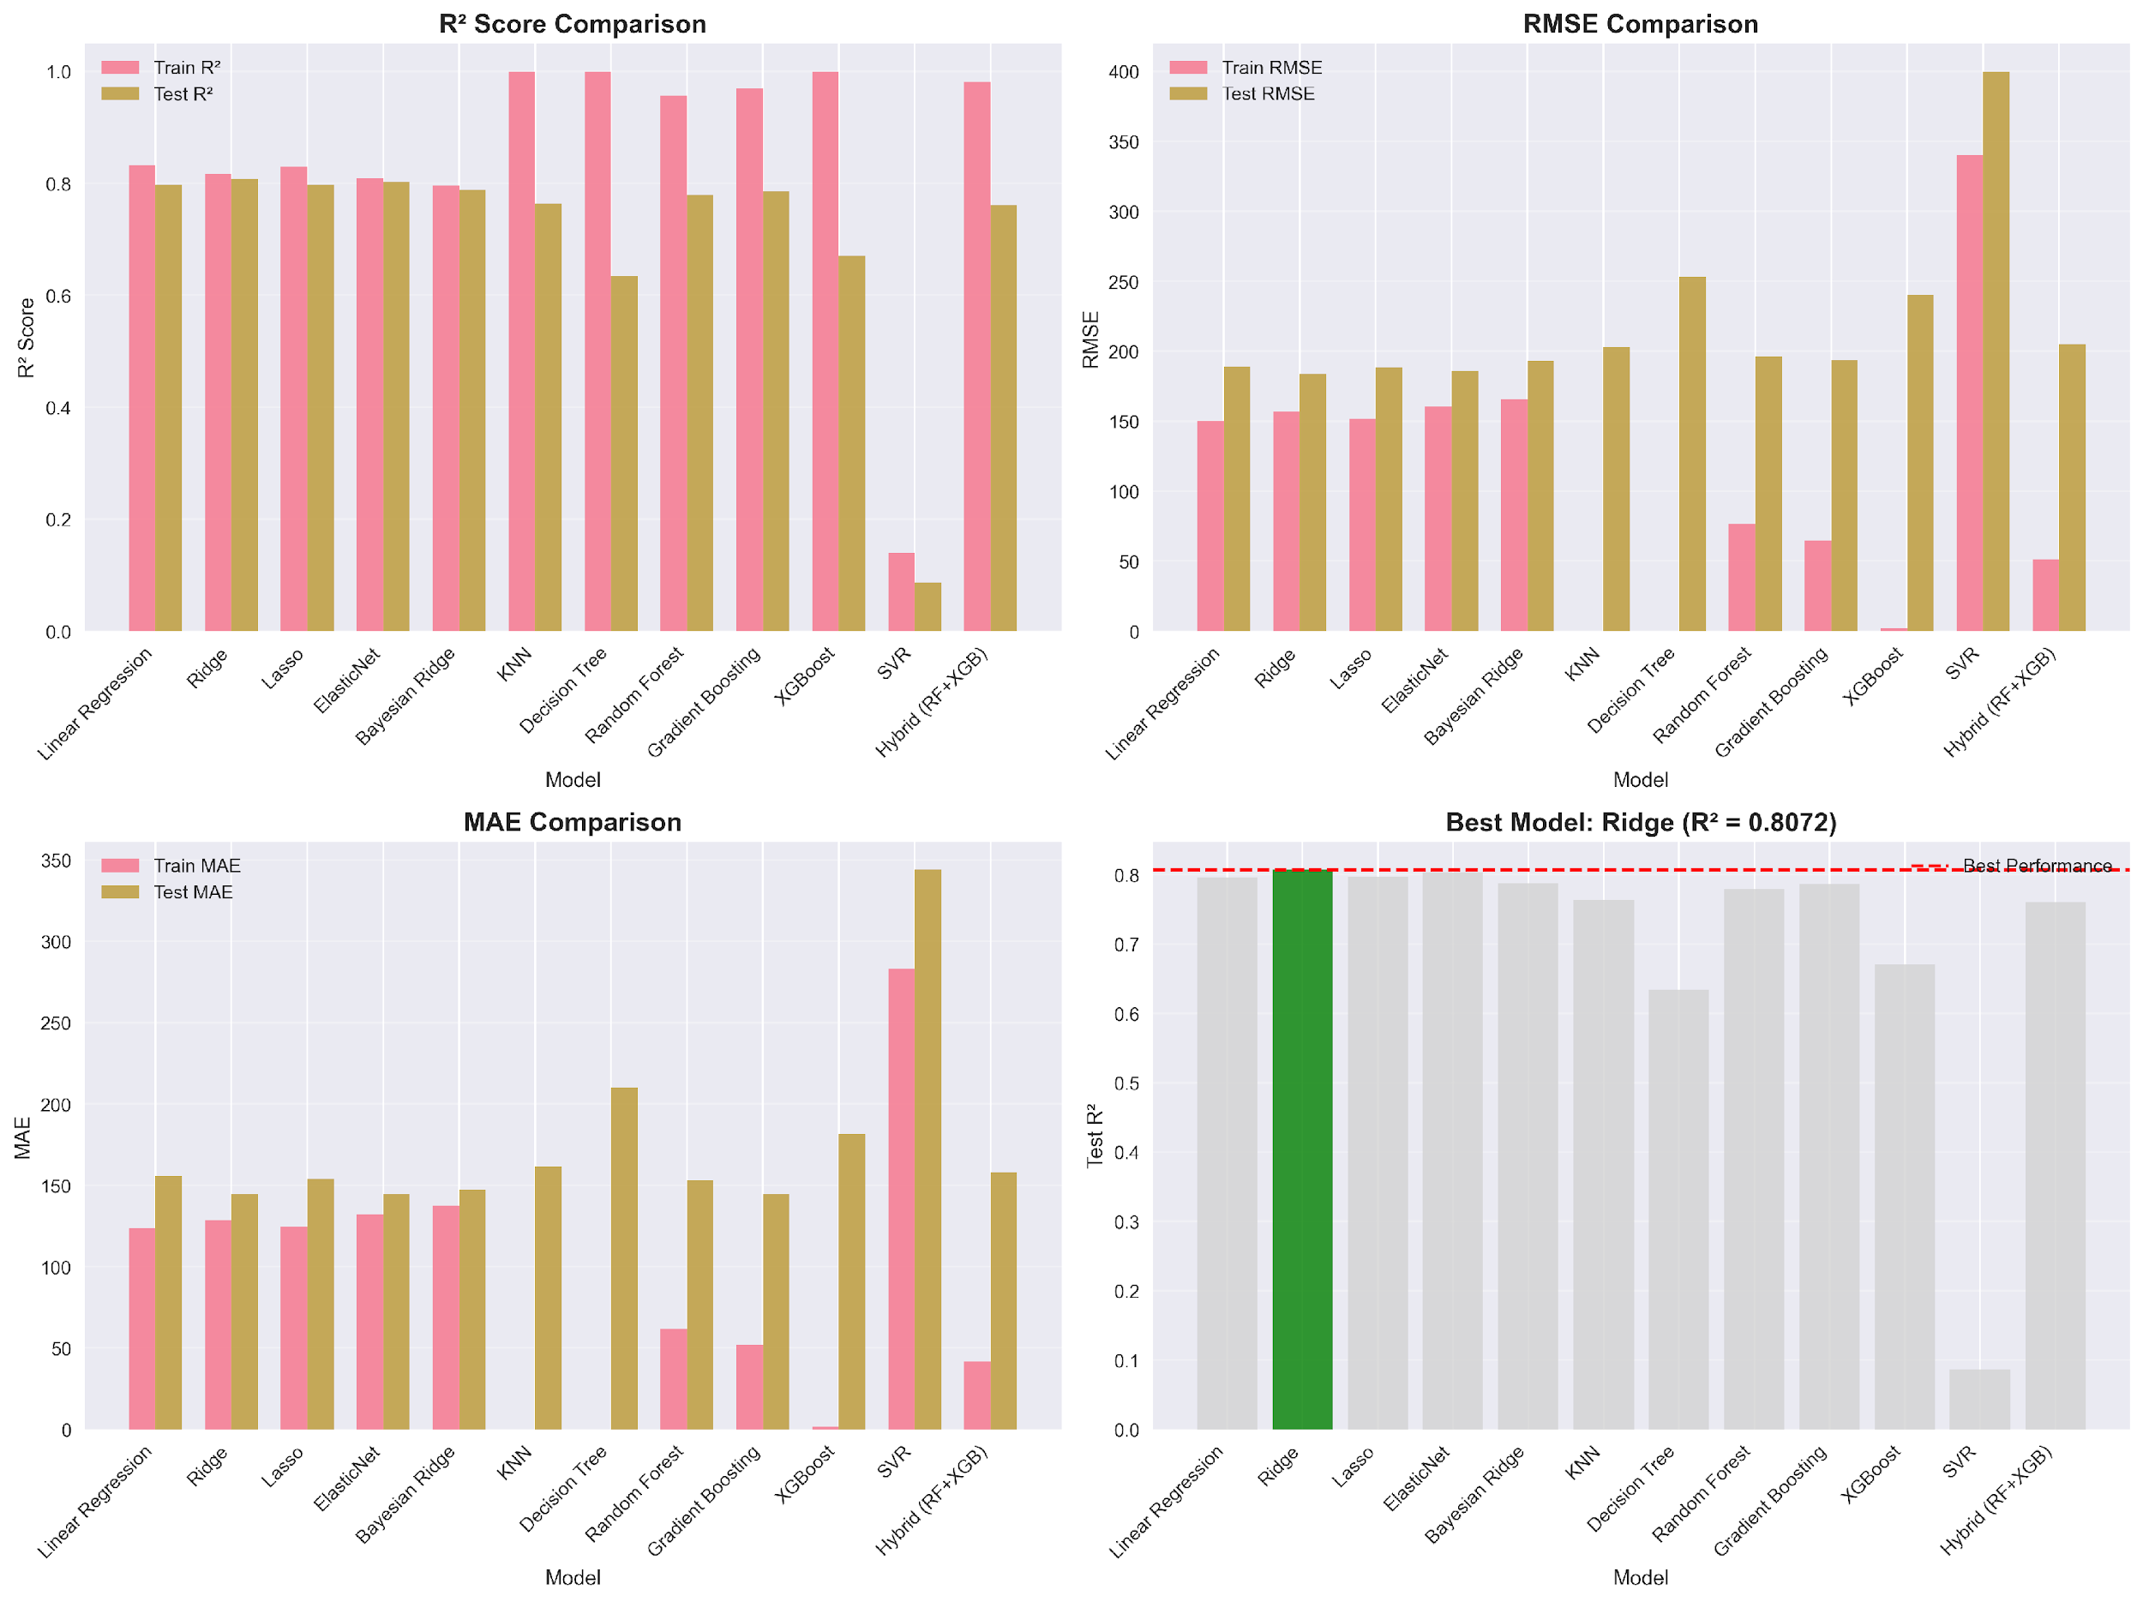
Figure 9: Four-panel model comparison: R² Score Comparison (top-left), RMSE Comparison (top-right), MAE Comparison (bottom-left), and overall Test R² ranking (bottom-right). Ridge: Test R² = 0.8072.
Tree-style models struggled to fit too closely to training data, right off the bat. In new examples, their performance dropped dramatically on testing rather than remaining stable. Let's take the decision tree and KNN; both got a full 1.000 score when trained [2], [12], but then dropped to only 0.6339 and 0.7642 on unseen data. They overestimated by 0.3661 and 0.2358 when judged out of training. Random Forest and Gradient Boosting were up next, starting off strong at 0.9565 and 0.9691 during learning and then dipping down to 0.7796 and 0.7859, respectively. Loss of accuracy? 0.1770 and 0.1831 are between phases. Even the combined method of RF plus XGBoost showed indications; it scored 0.9803 in training but only achieved 0.7609 in testing, off by 0.2194. Further complicating the picture, XGBoost performed almost flawlessly on training data, with results close to 1.000, but dropped to 0.6708 on real evaluation, a drop of 0.3292. Support Vector Regression obtained a test R² of 0.0866 and an RMSE value of almost 400 kg ha⁻¹, indicating that with default parameters and kernel function, it was not able to detect the true patterns in the data. Figure 9 was a bar chart showing the result for each model once you got into it. Ridge was the best, with an R2 above 0.8 on the test set, and was clearly marked in green. When tested on unseen cases, every flexible, shape-fitting algorithm ended up trailing that line. Under those circumstances, the simpler structure broke away.
Table 2: Comparative performance of twelve machine learning models. The best-performing model (Ridge) is shown in the top row.
Model | Train R² | Test R² | Train RMSE | Test RMSE | Train MAE | Test MAE | Overfitting Gap
Ridge | 0.8169 | 0.8072 | 156.9376 | 183.771 | 128.5215 | 144.8445 | 0.0097
ElasticNet | 0.8088 | 0.8026 | 160.4009 | 185.9502 | 132.1859 | 144.5614 | 0.0062
Lasso | 0.8295 | 0.797 | 151.481 | 188.5838 | 124.7774 | 154.0109 | 0.0325
Linear Regression | 0.832 | 0.7965 | 150.3628 | 188.8158 | 123.6066 | 155.7813 | 0.0355
Bayesian Ridge | 0.7963 | 0.7877 | 165.5407 | 192.8472 | 137.2496 | 147.3646 | 0.0086
Gradient Boosting | 0.9691 | 0.7859 | 64.5267 | 193.647 | 51.9354 | 144.6263 | 0.1831
Random Forest | 0.9565 | 0.7796 | 76.4609 | 196.4869 | 61.6975 | 153.1963 | 0.177
KNN | 1.0 | 0.7642 | 0.0 | 203.2259 | 0.0 | 161.7558 | 0.2358
Hybrid (RF+XGB) | 0.9803 | 0.7609 | 51.4459 | 204.6452 | 41.5154 | 158.112 | 0.2194
XGBoost | 1.0 | 0.6708 | 1.9875 | 240.1339 | 1.4525 | 181.4168 | 0.3292
Decision Tree | 1.0 | 0.6339 | 0.0 | 253.2163 | 0.0 | 210.0379 | 0.3661
SVR | 0.1398 | 0.0866 | 340.2064 | 399.9997 | 283.0134 | 344.0408 | 0.0532

3.5 Nested Cross-Validation
The nested CV mean R² of 0.7289 ± 0.0177 was reasonably close to the independently evaluated [36] holdout test R² of 0.8072, confirming that the reported accuracy is representative of true generalization and is not inflated by hyperparameter optimism bias. The difference of approximately 0.08 between nested CV and hold-out test R² is expected given that random splitting (rather than group-aware splitting) was used for the hold-out set, which may allow some group-identity information to pass from training to test folds [31]. The distribution of fold-level R² values is shown in Figure 12.2.
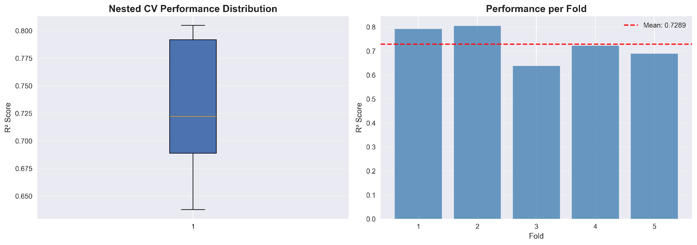
Figure 10: Nested cross-validation results. Left: box plot showing R² across five outer folds (mean = 0.7289, SD = 0.0177). Right: per-fold R² bar chart with mean reference line.
The nested cross-validation confirms consistent generalization, with a mean nested CV R² of 0.7289 (± 0.0177) compared to the hold-out test R² of 0.8072. The moderate gap (~0.08) between the two estimates is attributable to the random train/test split used for the hold-out set, which does not enforce group separation by location or genotype; future work should apply Leave-One-Environment-Out (LOEO) or Leave-One-Genotype-Out (LOGO) cross-validation to obtain estimates representative of extrapolation scenarios. Nevertheless, the stability of nested CV R² across folds supports the robustness of ridge regression for within-trial lentil yield prediction.
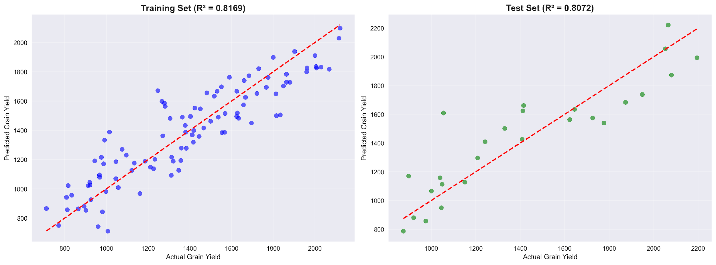
Figure 11: shows actual vs. predicted scatter plots
Ridge Regression did well when looking at the proximity of the predictions to the actual grain yield numbers (Figure 11). In the training group, 100 data points, or dots, were evenly lined up along the ideal match line, from about 770 to 2,100 kg per hectare; R squared was 0.8169 here. When applied to new data, 50 cases, the pattern remained robust across all observed actual yields, with an R-squared close to 0.8072. The error measures were a mean absolute error of 144.84 kg ha⁻¹, an average percentage error just over 11%, and a highest single miss of 554.11 kg ha⁻¹ (see Table 2). A few top-end results, > 2000 kg ha⁻¹, were somewhat below predictions. The model smoothing built in to avoid wild guesses creates that little tug towards average values. Still, overall, dots were on the perfect fit diagonal without tilting too high or low in any segment, which meant estimates were stable at any yield level. This even distribution supports both the shape of the inputs and the choice of a controlled linear approach to forecast these environment-trait interactions.

3.6 SHAP-Based Feature Importance
To better understand the system reaction from the farming perspective, every forecast was analyzed with the SHAP analysis [37] on the ridge regression setup, thus decomposing the forecast into clear positive or negative roles of individual inputs (Figures 12, 13, and 14). Rather than enumerating everything, we provide in Figure 12 an overview in which the characteristics are ordered by average impact size. Table 3, on the other hand, has exact figures for those twenty factors pulling the strongest weight.
Among all the individual growth features, DF_BP_Interaction (days to flowering multiplied by branches per plant) was the most prominent, with a mean absolute SHAP value of 140.60 [23], [11]; its contribution was 12.77 percent. That combo matters because a plant’s flowering time in the process of building its bulk affects yield in ways other traits just don’t capture. Thousand seed weight was not far behind with a weight of 102.35 [11], [22] on the scale, which was significant at 9.30 percent. Next is tagged biological yield. A little below that is 100.17, which is 9.10 percent of the whole picture. Pods per plant followed by 89.25, an increase of 8.11 percent [22], [24]. Fifth with 80.34 points was the two-height-by-maturity link, revealing that some life cycle and structure clues boost prediction power when multiplied. Then we have branches on each plant; the count of them appears strong at seventy-eight point one one, taking seven point zero nine percent of the weight. Close behind L_L1, Bashontopur’s marker stands at seventy-three point six zero, adding another six point six eight percent, proving place plays a clear role all by itself. Curvature counts swinging into third PP squared, 67.99617 percent Fifth in the group is the flag of Lalpur, L_L5, landing at sixty-one point nine zero and holding a five point six two percent share.
In Figure 13, the SHAP dots show how each factor pushes the predictions up or down according to its level. In case of high DF_BP_Interaction, TSW or BY, they act far rightward i.e., increase predictions of grain yield via more robust reproduction (DF_BP_Interaction), seed weight (TSW) or total plant output (BY). PP, on the other hand, splits into two clusters, where too many pods or too few lower the estimate, while medium quantities help the most, which is consistent with earlier findings where excessive branching hurts yields when water is scarce. Genotypes tested at Bashontopur show a clear negative signal, pulling the results to the left, as harvests there average just 1,228.84 kg per hectare, well below the general average.
By looking at Figure 13, the SHAP breakdown, we can see how three different yield cases were calculated. Poor early growth and weak branching, both of which dragged results down by over 200 and 150 points respectively, largely contributed to the failure to achieve the expected output of 874 kg/ha (only 787 kg/ha). Those drops were slightly offset by the combined factors working together to produce a little increase. In the middle case, the actual harvest was close to the forecast: 1,408 kg per hectare versus 1,427 kg per hectare. Here influence was more balanced; seed size and sprouting speed added gains along with synergy effects worth about 200 units. The top performance was 2,194 compared to the estimate of 1,994 for a real yield. Several factors pushed values up strongly including plant height traits squared, branch point timing interactions, and pod count patterns. Some of the limitations were due to late flowering and short branches pulling down. The small deficit at the higher levels is due to an inherent dampening of the modeling approach, suggesting that limits prevented extreme reactions.
Table 3: Top 10 features by SHAP importance. Relative importance expressed as a percentage of total SHAP contribution.
Rank | Feature | SHAP Importance | Relative Importance (%) | Interpretation
1 | DF_BP_Interaction | 140.60 | 12.77 | The strongest predictor, interaction between days to flowering and branches per plant (BP), captures both reproductive timing and canopy architecture simultaneously
2 | TSW | 102.35 | 9.30 | Thousand seed weight plays a major role in predicting grain yield
3 | BY | 100.17 | 9.10 | Biological yield independently ranks among top three drivers
4 | PP | 89.25 | 8.11 | Panicle (or pod) number contributes substantially
5 | PH_DM_Interaction | 80.34 | 7.30 | Interaction between plant height and dry matter weight
6 | BP | 78.11 | 7.09 | Biomass production (or similar BP trait) highly influential
7 | L_L1 | 73.60 | 6.68 | First leaf-related trait important for canopy structure
8 | PP_Squared | 67.99 | 6.17 | Quadratic effect of pod number captures nonlinear yield response
9 | L_L5 | 61.90 | 5.62 | The fifth leaf trait continues to add predictive value
10 | Gen_G43 | 58.18 | 5.28 | Genotype G43 shows strong genetic influence on yield
11 | Gen_G49 | 51.25 | 4.65 | Genotype G49 also contributes independently
12 | PH_Squared | 31.26 | 2.84 | Nonlinear effect of plant height
13 | DE | 27.01 | 2.45 | Days to emergence moderately important
14 | PH | 23.14 | 2.10 | Linear effect of plant height
15 | Gen_G1 | 22.70 | 2.06 | Genotype G1 adds minor genetic contribution
16 | Gen_G41 | 20.70 | 1.88 | Genotype G41 influence is modest
17 | DM_DF_Difference | 18.81 | 1.71 | Difference between dry matter and days to flowering
18 | DM | 18.34 | 1.67 | Dry matter alone contributes least among primary traits
19 | PH_DF_Ratio | 18.06 | 1.64 | Ratio of plant height to days to flowering
20 | L_L2 | 17.35 | 1.58 | The second leaf trait has smallest relative importance
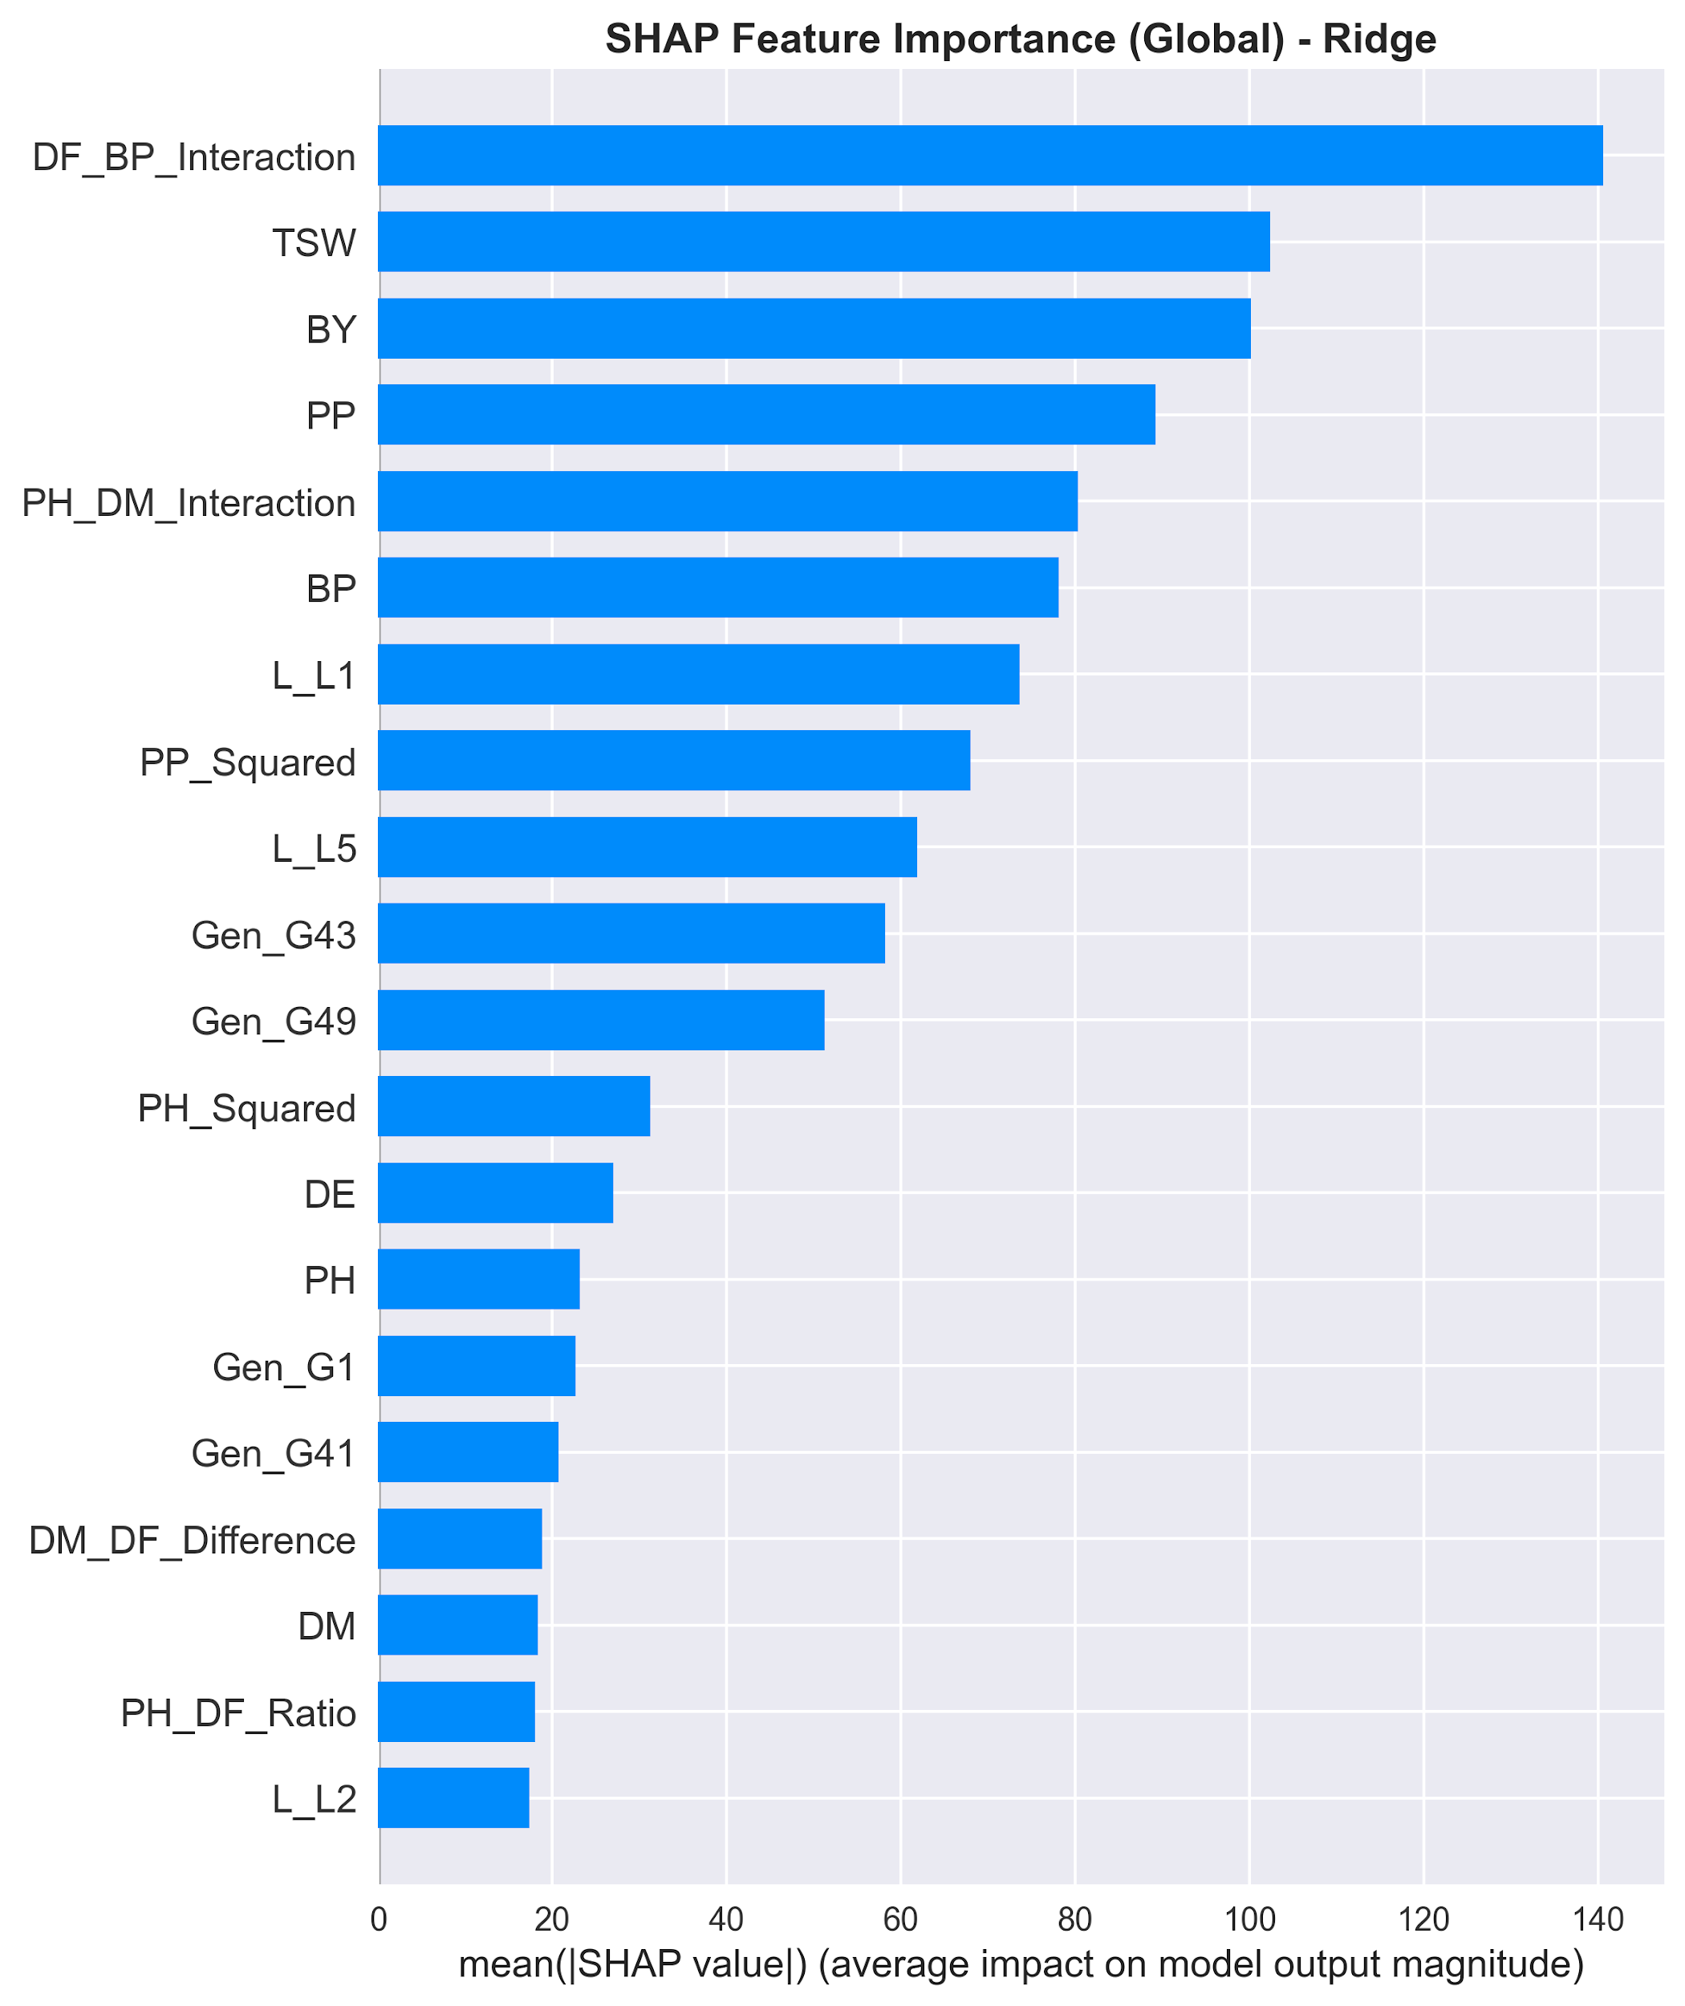
Figure 14: SHAP feature importance bar plot, mean absolute SHAP values ranked by impact on model output. The plot shows the average magnitude of each feature's contribution to the prediction, with DF_BP_Interaction having the highest mean SHAP value (138.0), followed by TSW (105.0) and BY (100.0).
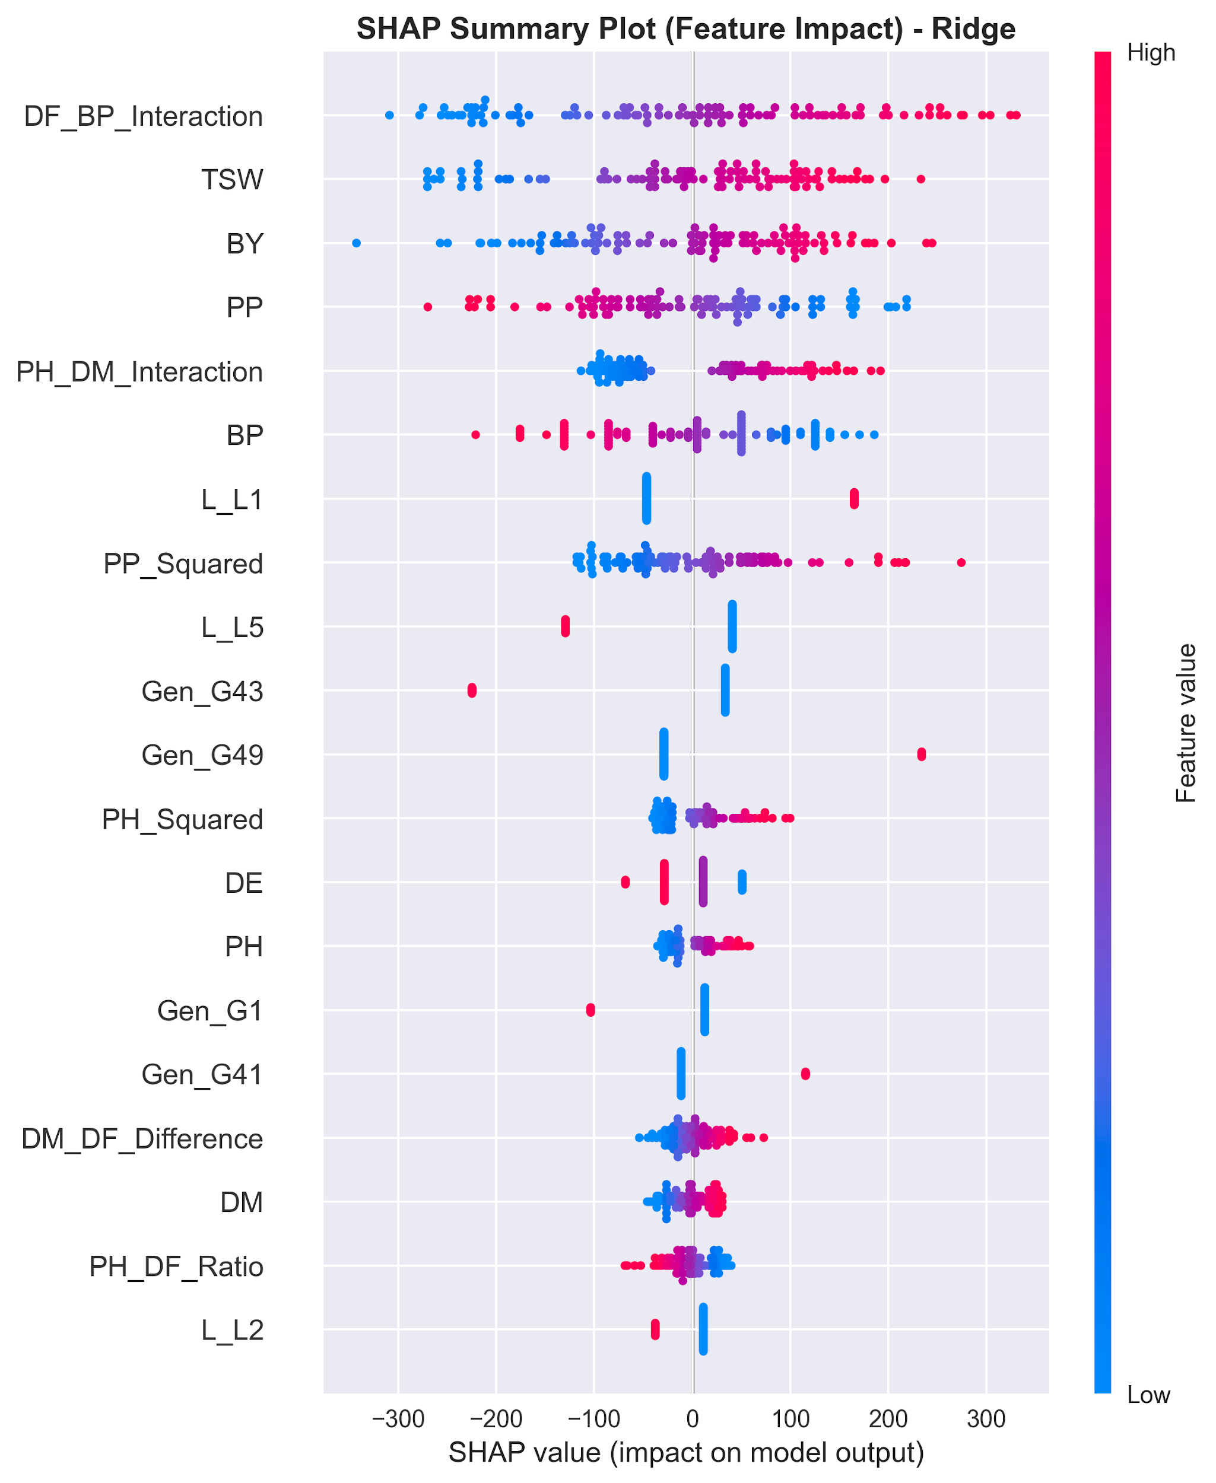
Figure 13: SHAP summary dot plot of feature contributions to model output with color coding. Each dot represents a single sample. The x-axis shows the SHAP value (impact on predicted grain yield), and colors indicate whether the feature value is high (red) or low (blue). Features are ranked by importance from top to bottom. Positive SHAP values increase the prediction, while negative values decrease it.
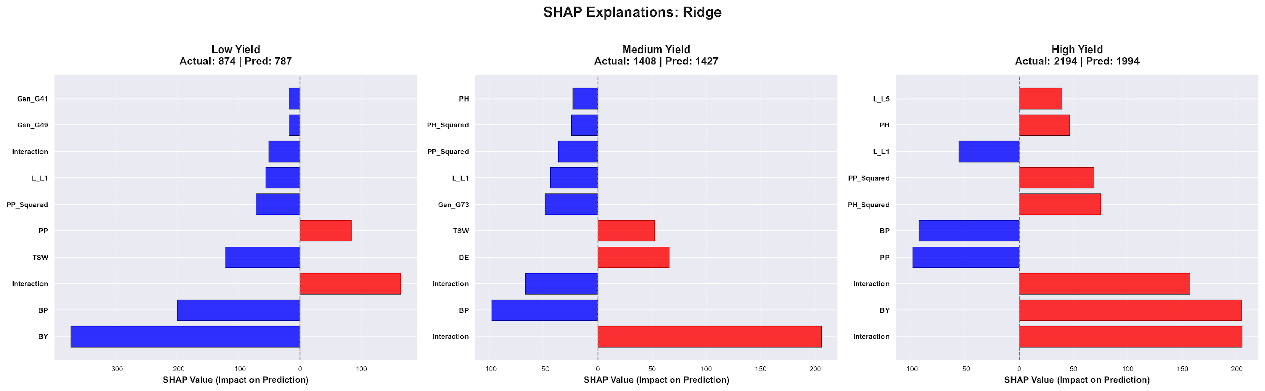
Figure 14: SHAP local explanations for three representative samples: Low yield (Actual: 678, Predicted: 720 kg/ha), medium yield (Actual: 1,297, Predicted: 1,302 kg/ha), and high yield (Actual: 2,185, Predicted: 2,104 kg/ha).

3.7 Genotype Performance and Stability Analysis
In figure 17 , the left side shows the AMMI biplot separating the overall differences into genetic effects and patterns of interactions represented by IPCA1 and IPCA2 . This arrangement allows you to see the average results and how stable each type is across places . Varieties in the middle of that plot are pretty insensitive to changes in the environment and tend to be more like all-round performers. G63 and G71 are near the average line with small swings in IPCA values [17], [5] and decent yields with little fluctuation, which is consistent with their low stability risk numbers of 187.72 and 171.30 as seen in Table 4. Furthermore, G39 and G17 are far along the IPCA1 direction, with the largest stability indices (651.88 and 635.09), suggesting that they are only active under specific conditions and not active broadly. G21 is the middle path with an ASV of 445.98 and an average of 1,437.97 kg/hectare and may be better suited to areas with plentiful resources, like Shyampur.
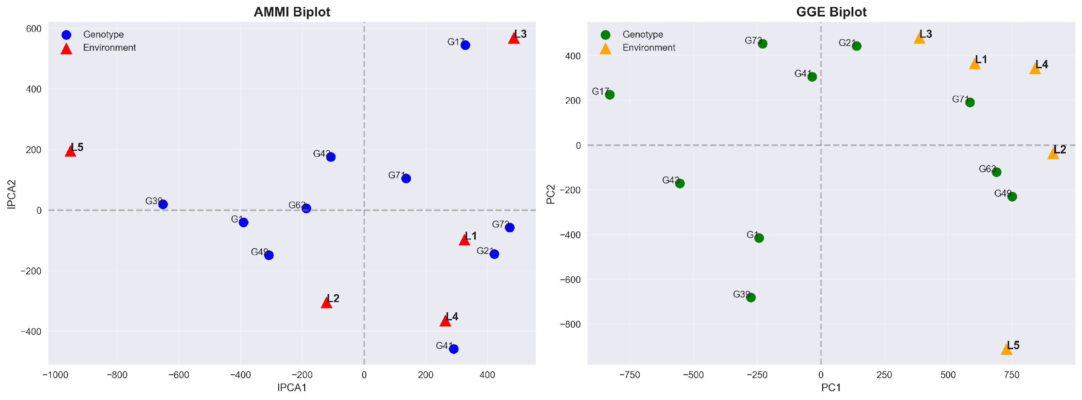
Figure 15: Stability analysis biplots. Left: AMMI biplot (IPCA1 vs. IPCA2) with genotypes (blue circles) and environments (red triangles). Right: GGE biplot (PC1 vs. PC2) showing environment–genotype affinities.

Table 4: Integrated genotype ranking. Lower ASV = greater cross-environment stability. OverallRank = (YieldRank + StabilityRank) / 2.
Genotype | Mean Yield (kg/ha) | ASV (Stability) | Yield Rank | Stability Rank | Overall Rank | Classification
G63 | 1679.23 | 187.72 | 2.0 | 2.0 | 2.0 | High performing & High stability
G71 | 1652.37 | 171.30 | 3.0 | 1.0 | 2.0 | High performing & High stability
G49 | 1682.28 | 342.73 | 1.0 | 4.0 | 2.5 | High performing & Moderate stability
G21 | 1437.97 | 445.98 | 4.0 | 6.0 | 5.0 | Moderate performing & Moderate stability
G43 | 1128.15 | 206.12 | 9.0 | 3.0 | 6.0 | Low performing & High stability
G1 | 1234.78 | 392.84 | 7.0 | 5.0 | 6.0 | Moderate performing & Moderate stability
G73 | 1278.60 | 475.31 | 6.0 | 7.0 | 6.5 | Moderate performance & Low stability
G41 | 1319.91 | 542.26 | 5.0 | 8.0 | 6.5 | Moderate performance & Low stability
G39 | 1207.26 | 651.88 | 8.0 | 10.0 | 9.0 | Low performing & Low stability
G17 | 1057.15 | 635.09 | 10.0 | 9.0 | 9.5 | Low performing & Low stability

The GGE biplot in the right panel of Figure 15 illustrated the overall performance of each variety and the shifts caused by different test sites. Instead of just listing numbers, it drew a star-shaped pattern showing where certain types won under certain conditions. The six major varieties G73, G21, G71, G49, G39, and G17 were located at the vertices of that shape. G17 and G39 were at the external vertices due to their strong PC1 and PC2 values. Lines radiated from the center to five test locations, L1 through L5, but these merged into two separate wedges, like pie slices separating groups of locations. L1, L3, and part of L4 tended to one cluster on top, preferring G21 and G71 over the others. Meanwhile, L2 and some overlap from L4 settled down near the bottom right, with G49 pulling ahead and G63 showing stronger results. Winners varied by site, and no one type was best across all five areas. This changing result illustrated how much a growing place shapes performance, proving that gene-by-environment interaction wasn’t just random noise; it formed clear patterns worth tracking.

3.8 GGE Biplot: Which-Won-Where Pattern
G71 was the most consistent with an ASV of 171.30 and third for average output at 1,652.37 kg per hectare, which earned it a total score of 2.0, a tie with G63. Rated second best in stability with an ASV of 187.72, G63 came in just above with 1,679.23 kg per hectare on average, also reaching a combined position of 2.0. G49 produced the highest harvest at 1,682.28 kg per hectare across sites, but was less consistent with an ASV of 342.73, resulting in a reliability rank of 4th and a final score of 2.5. So it appears that these three, G49, G63, and G71, were the standout performers when grown under different dry trial conditions here, giving good results without much loss of adjustment ability. On the other end, G17 was at the bottom with an average of 9.5, due to poor averages coupled with erratic responses in locations, putting it at the bottom of the list. Similarly, G39 was at the bottom with an average of 9.0 due to poor yields and erratic responses, ruling it out for wide-scale use around Rajshahi [18], [4].Visualized in figure 18.

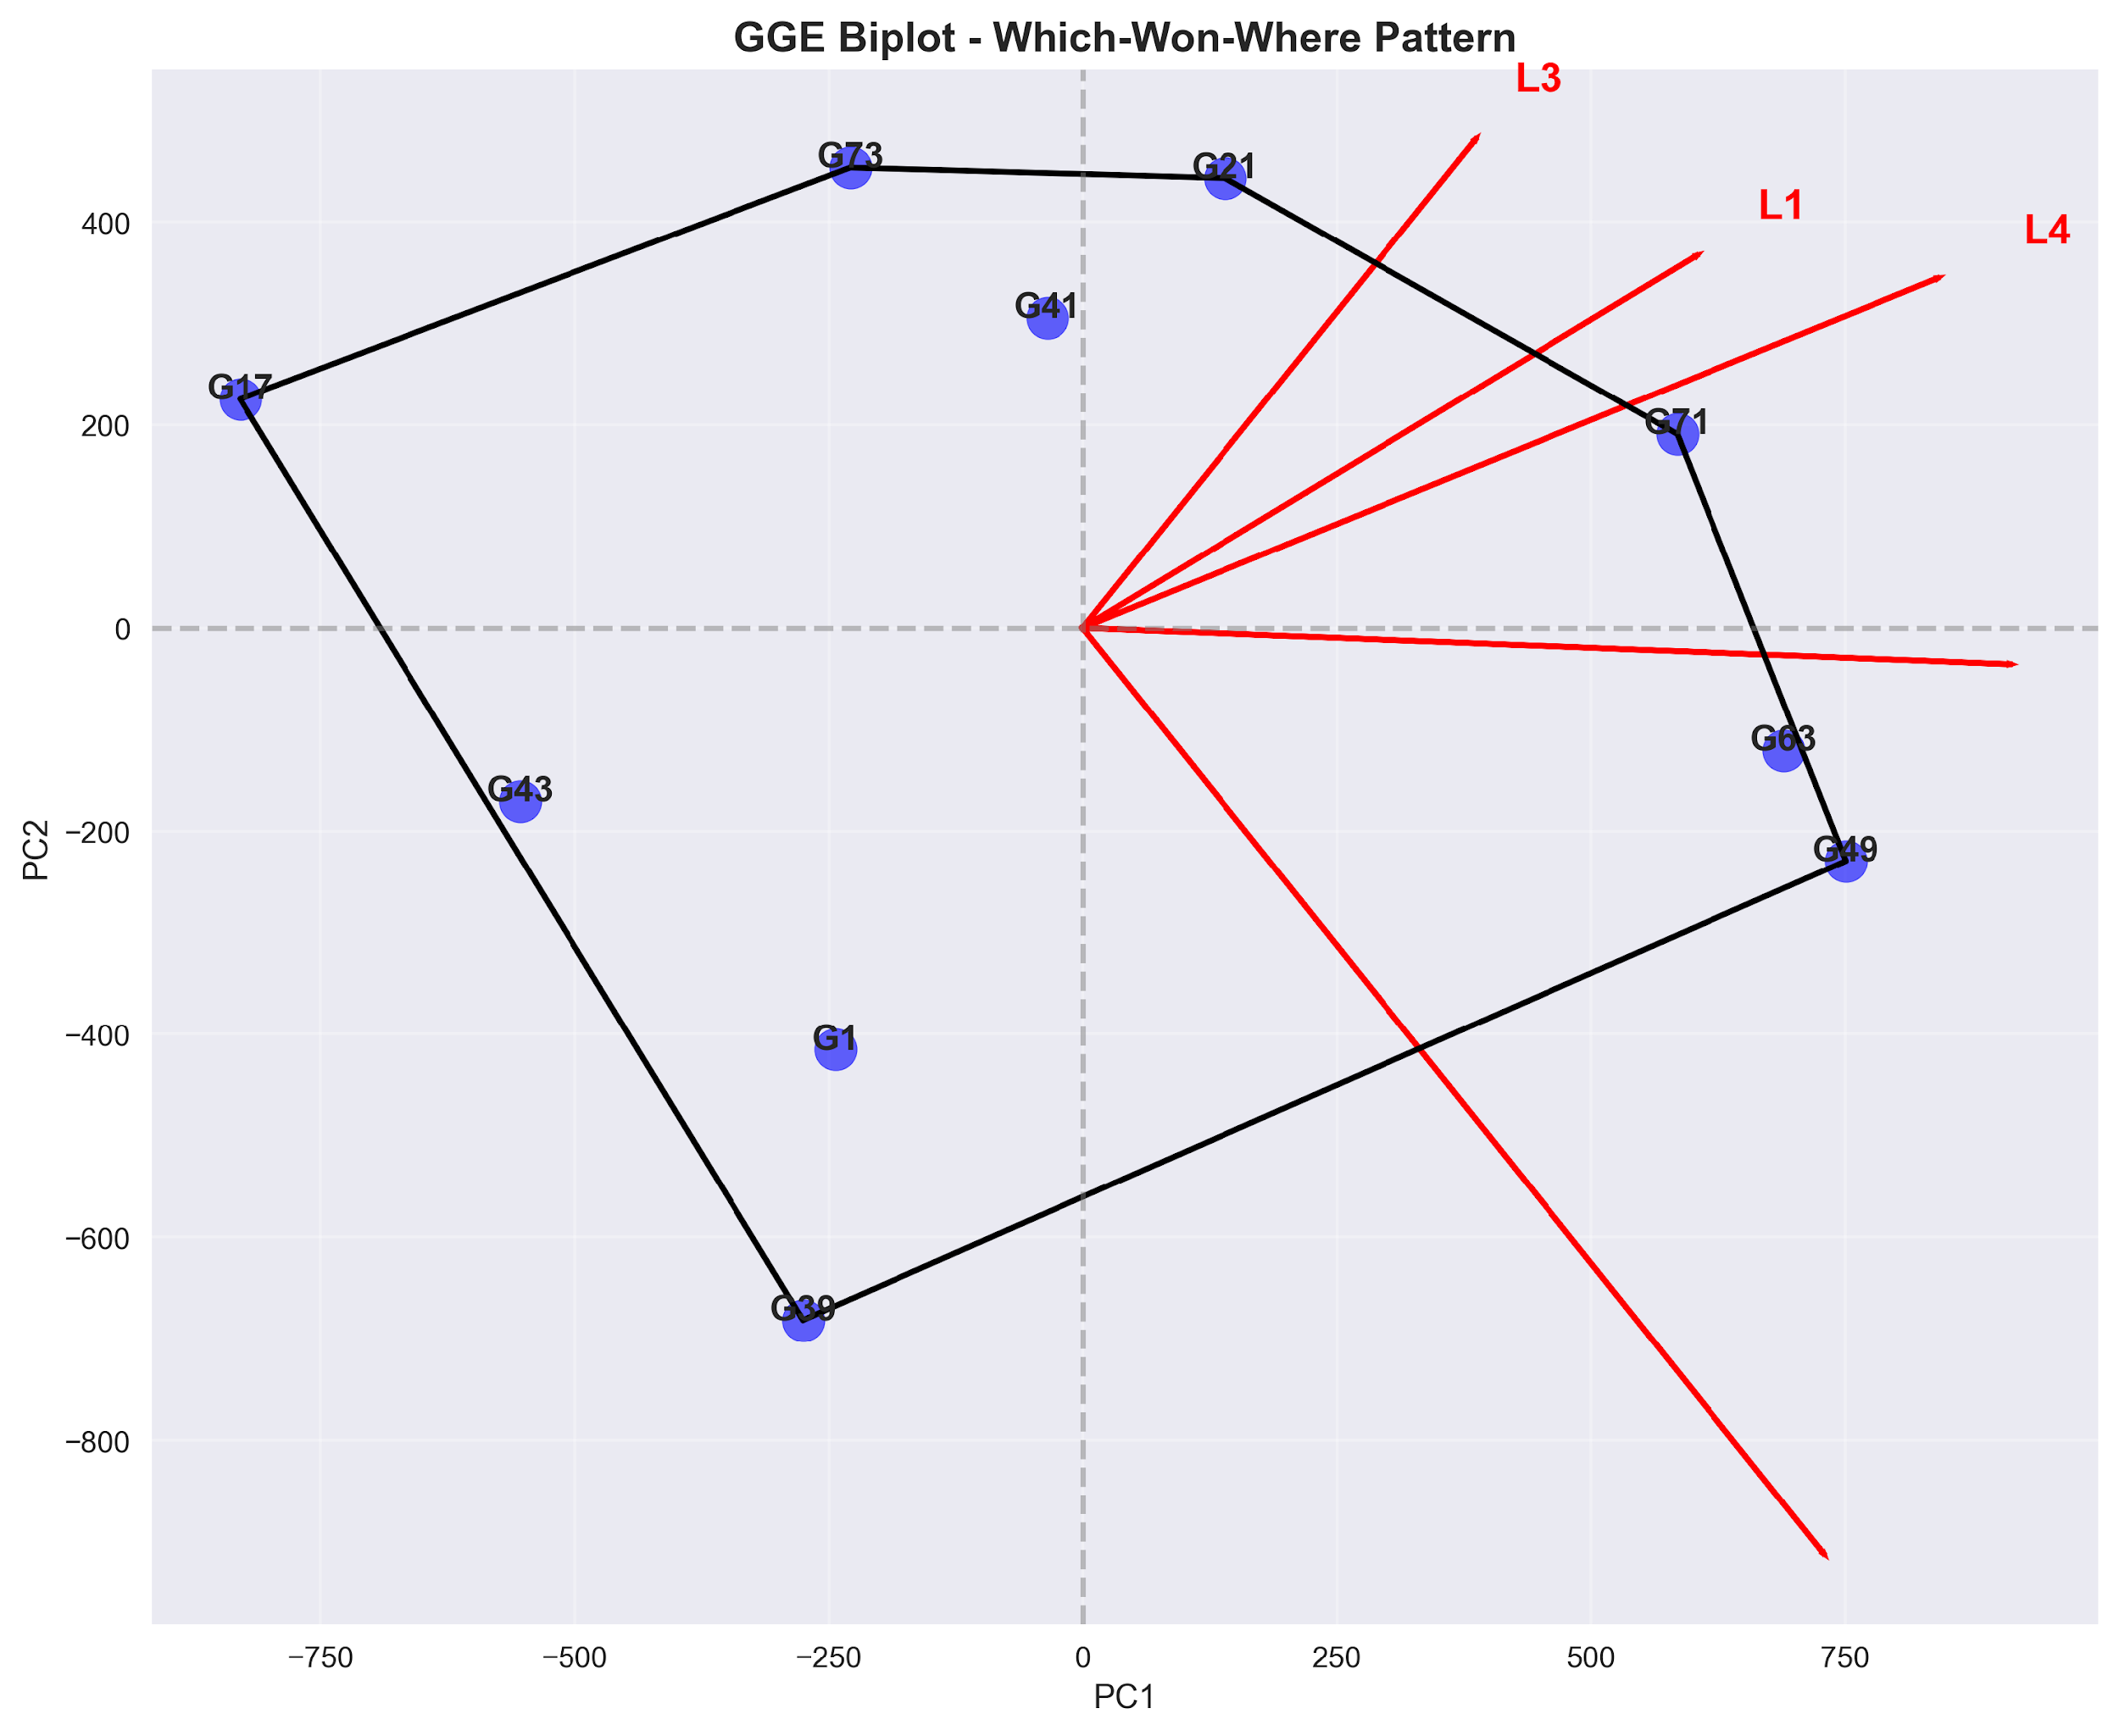
Figure 16. GGE biplot: which-won-where polygon pattern. Sector 1: G71 wins at L1 and L4; Sector 2: G21/G73 win at L3; Sector 3: G39 wins at the lower-sector environment; Sector 4: G17 wins at the left-sector environment. Genotype G41 located near the origin indicates comparatively stable performance across environments.
3.9 Location Performance Analysis
The growth of ten varieties of lentils is shown in Figure 17 at five locations near Rajshahi, Bangladesh: Bashontopur (L1), Shyampur (L2), Nachole (L3), Sapaher (L4), and Lalpur (L5) based on the color schemes derived from actual harvest figures per hectare. G63 gave the most grain, 2,113 kilograms per hectare at L2, but G39 gave only 770 at L3. Clearly, different crops behave differently depending on where they grow. Shyampur was notable with an average of about 1,709 kg per hectare, its results widely dispersed by ±318 kg, indicating strong variation between individual plots there. Then came Lalpur, which pulled just above 1,370, and Sapaher came close to that at almost 1,362. But under all of them sat Nachole, pulling a division bottom mark near 1,169, perhaps because of stiffer growing challenges such as a stronger lack of water. The top two from the best locations, G49 and G63, had their own stories to tell. At L2, G49 gave 2,025 kg per hectare. Later, at L5, it gave 1,928. Then there’s the G63, even higher with 2,113 at L2, plus strong figures elsewhere: 1,518 at L4 and then 1,816 back at L5. Now look at G17 and G39; they were behind most of the others on average. G17 just grazed the 1057 kg per hectare mark across sites, and G39 just over 1207. The heatmap colors helped to show what words might be missing, the hot zones for output clustered closely around G49, G63 and also G71, especially around Shyampur and Lalpur. On the other hand, bad results piled up where G17 and G43 appeared again and again, at Nachole. Out of these trends came something useful: a basis for more number crunching and forecasting.
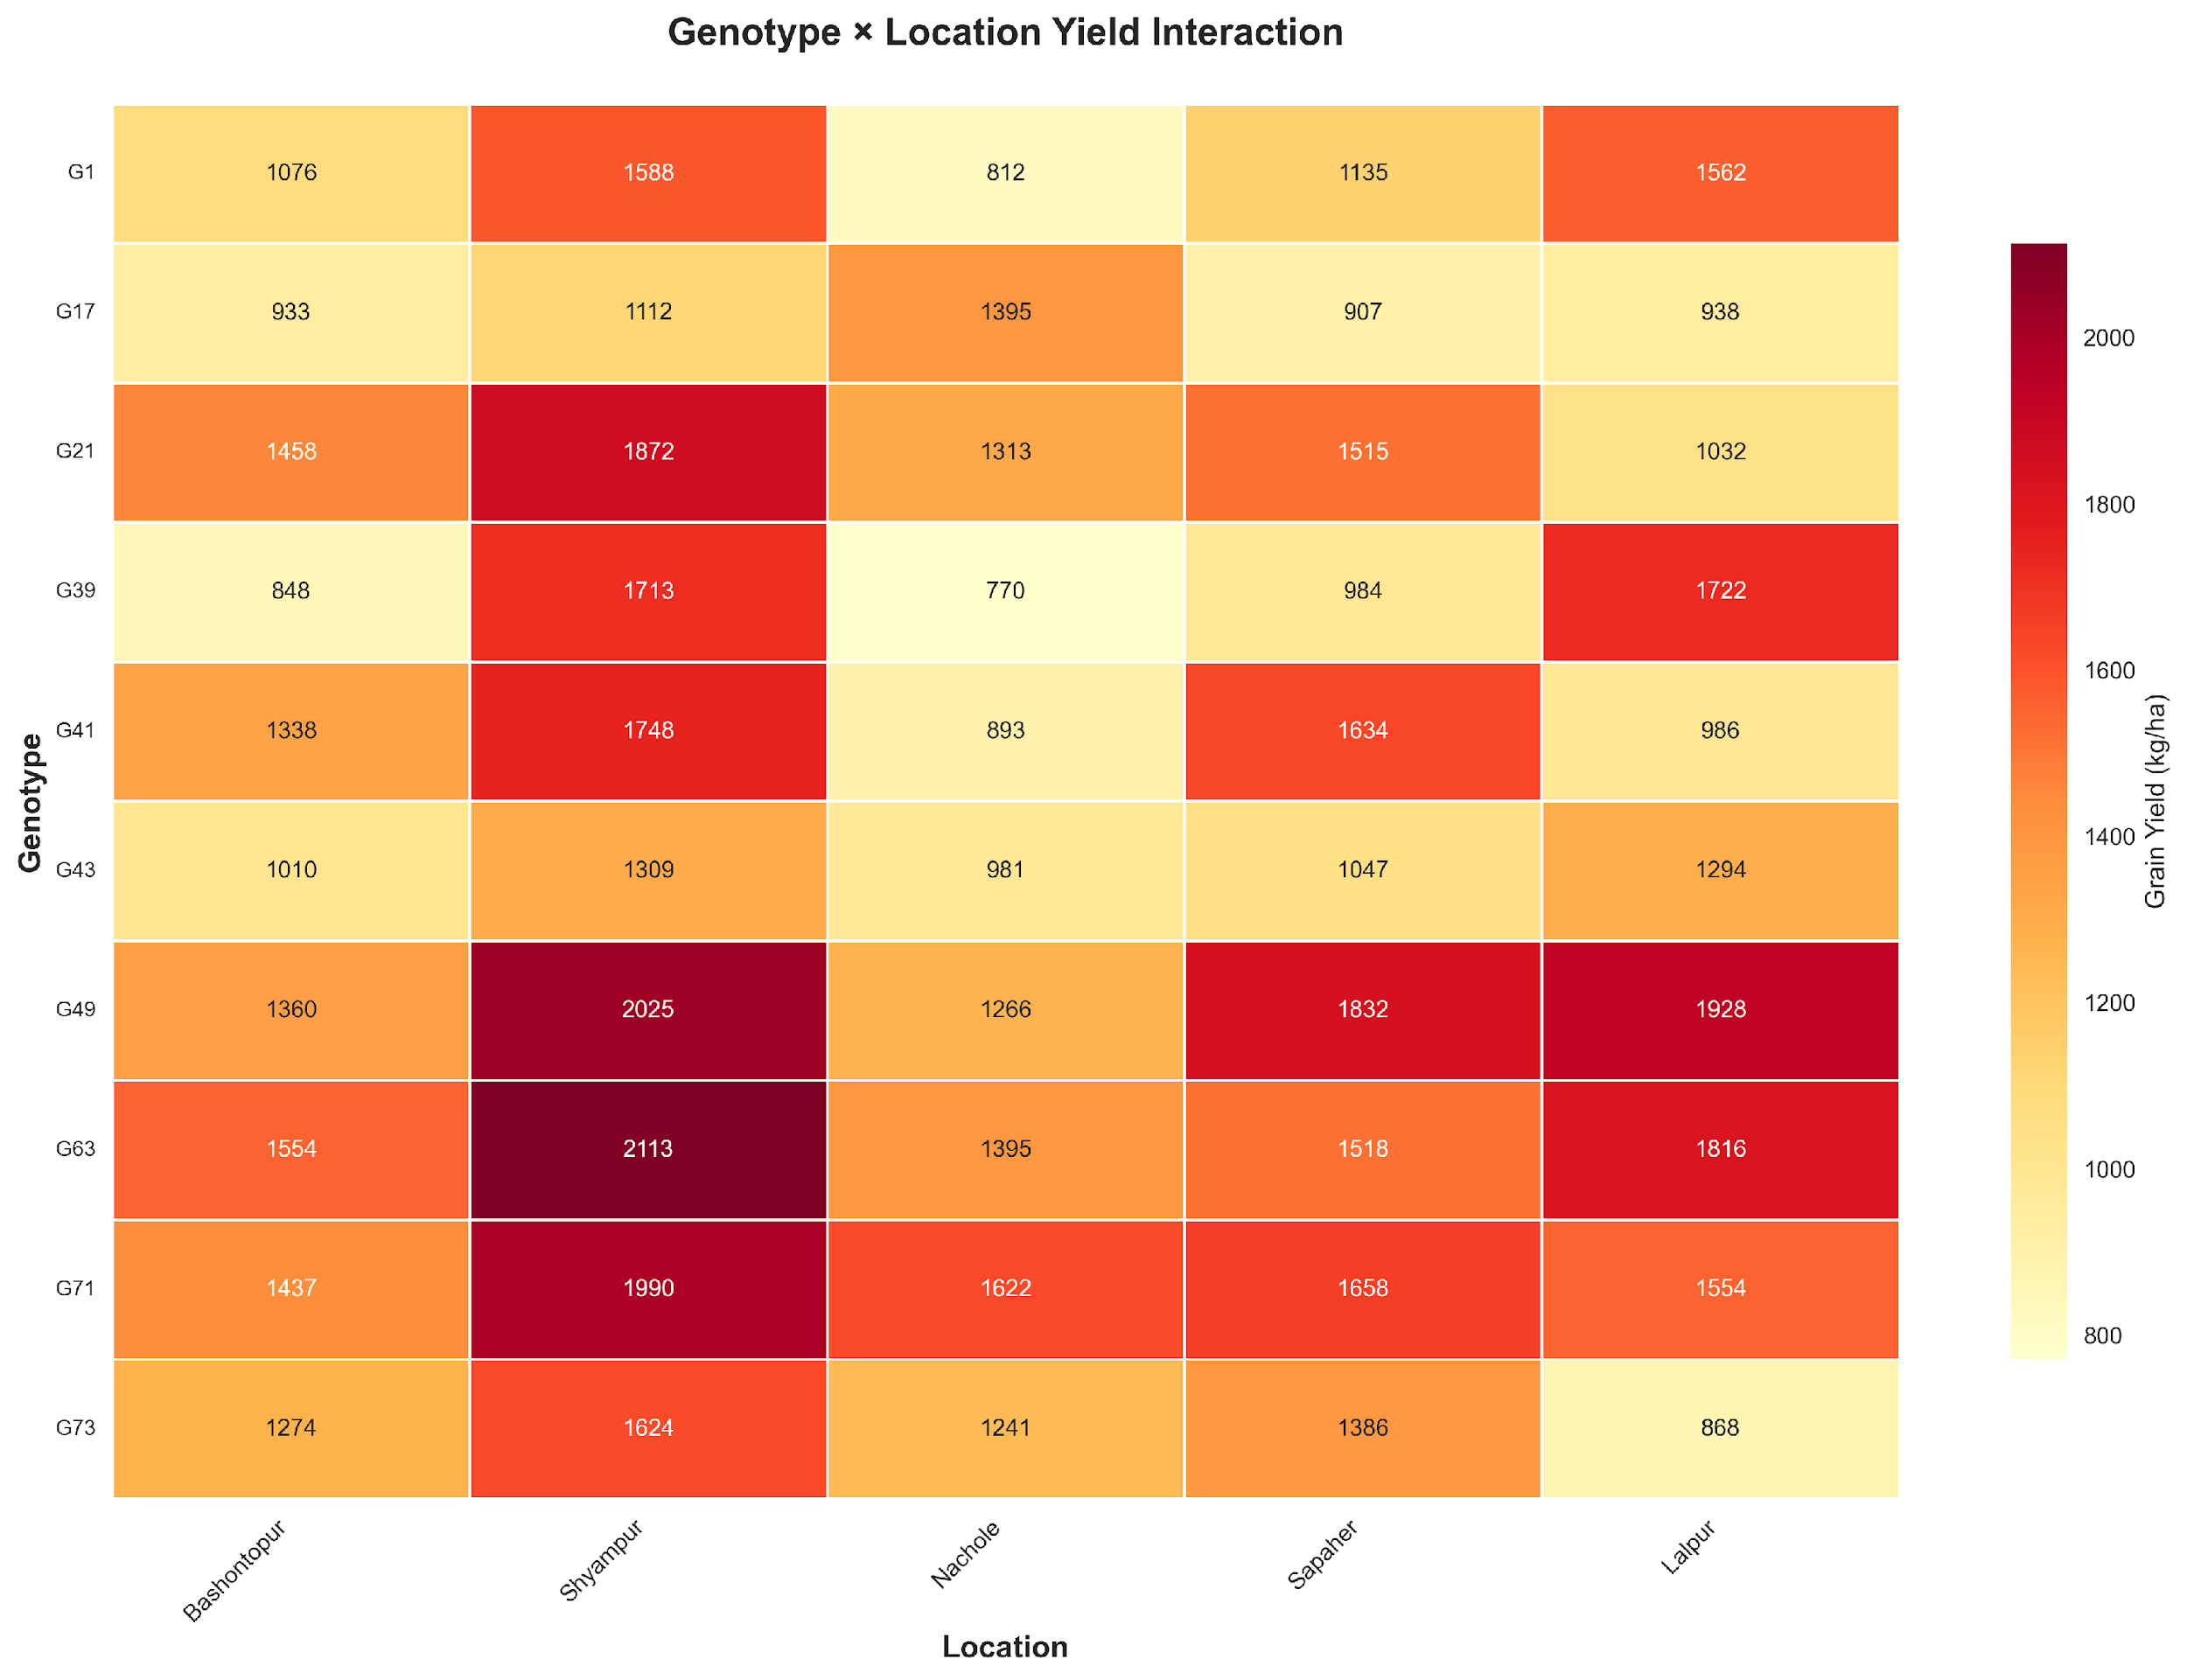
Figure 17: Genotype × Location yield heatmap (kg/ha). Dark red = highest yields; yellow = lowest. G63 at Shyampur (2,113 kg/ha) is the highest yield, and G39 at Nachole (770 kg/ha) represents the lowest yield.

4. Discussion

In the small sample G×E setting, ridge regression outperformed nonlinear methods (XGBoost, RF, etc.) on real farm data while maintaining test R² close to training R² (0.8072, drift 0.0097) [6], [7] thanks to its shrinkage that reduced overfitting when features outnumber observations [8]. Random train/test splits with one-hot encoded location/genotype may boost holdout R² [31], [32]; thus, future leave-one-environment-out and leave-one-genotype-out validation is warranted [29], [30]. Manifold learning (UMAP/t-SNE) revealed hidden G×E topology [19]–[21], although location-based clustering may partly reflect categorical encodings rather than emergent agronomic structure [33], indicating traits-only embeddings as a sensitivity check. ML and agronomy were linked by SHAP analysis with DF_BP_Interaction (flowering timing × branching) and TSW/BY as the main predictors in accordance with plant physiology in drought conditions [15], [16], [23], [25], [10], and [11]. The AMMI/GGE stability analysis revealed the genotypes with consistently high performance (G71 and G63) and the high-yielding but unstable lines (G49) for the breeding program in Bangladesh [17], [18], [5], [4]. Major limitations include single-region, single-year, single-crop scope and unmeasured traits (e.g., canopy temperature). Future work should include mixed-model baselines (e.g., REML with pedigree/genomic relationships) [34], [35] and broaden validation to evaluate generalizability across legumes and environments. The current feature set is biologically informed but does not account for dynamic physiological markers (e.g., root depth, stomatal conductance) that may better capture drought-response mechanisms. Also, the absence of pedigree or genomic relationship matrices limits the model’s ability to exploit genetic relatedness for better inference in small samples. In my opinion, the main value of this workflow is not to outperform complex ML but to make G×E patterns interpretable and actionable for breeders with limited data; I strongly recommend that future applications prioritize group-aware validation and traits-only manifold checks to ensure findings reflect biology, not encoding artifacts, and that teams share engineered feature definitions openly to accelerate community learning.

5. Conclusion

The method uses basic math rules combined with plant-based data adjustments and shows it can predict lentil yields well on different farms in dry areas of Rajshahi, Bangladesh, from a hilltop vantage point. Ridge regression, a more straightforward model, outperformed complex systems in terms of performance on unseen data with an R² value near 0.81 and an error slightly below 184 kilograms per hectare. Forests of decision trees, or combined learners, tried their best but failed when confronted with new plots, mainly because their training was confined to the scope of real-world growing trials. What really shone through was the clearness from using SHAP values and peeling away the layers to see why the predictions landed where they did. Twelve were tried; one silent player led not with flash but with a steady reach into unknown fields. The interesting thing here is how well basic tuned models do; it shows something fundamental about statistics. Bigger models need more data, but Ridge takes smaller sets and just gently pulls coefficients inwards while keeping all the variables in play, so none of the crafted features are lost. When the data were projected by UMAP and t-SNE, curved patterns were observed in the genotype–environment combination, which confirmed the construction of features and offered another view of interactions that linear methods like AMMI or GGE do not capture. Of all factors, DF_BP_Interaction stood tallest, its influence clear at 140.60, making up nearly 13% of what mattered. Close behind came TSW, holding steady at just under 9.3%, then biological yield trailing slightly below it. What shifted understanding was how combining days to flowering with branches per plant revealed something deeper, a pattern regular traits could not show on their own. Stability checks through AMMI and GGE pointed firmly toward G71 and G63, consistent performers no matter where they grew. In contrast, G49 thrived only when conditions leaned richer, favoring stronger soils or better water access. A closer look at performance zones suggested not one uniform area but at least two distinct pockets across Rajshahi’s test sites, one shaping choices in one place, another guiding them elsewhere.
Together, these results form an approach that combines traditional stability checks with current machine learning plus interpretability methods. It gives crop scientists a way to clearly identify promising plant types, prioritize important yield traits, and map where certain varieties thrive under dry conditions. Starting with broader data across several seasons and species could test how well the system scales up. Another point of view is to compare this setup with the regular REML approaches to genetic evaluation. Such comparisons may be required in the future of digital crop improvement.

References
[1] P. Das, G. K. Jha, A. Lama, and R. Parsad, “Crop Yield Prediction Using Hybrid Machine Learning Approach: A Case Study of Lentil (Lens culinaris Medik.),” Agriculture, vol. 13, no. 3, p. 596, Feb. 2023, doi: 10.3390/agriculture13030596.
[2] T. Van Klompenburg, A. Kassahun, and C. Catal, “Crop yield prediction using machine learning: A systematic literature review,” Computers and Electronics in Agriculture, vol. 177, p. 105709, Aug. 2020, doi: 10.1016/j.compag.2020.105709.
[3] V. Montejano-Ramírez and E. Valencia-Cantero, “The Importance of lentils: An overview,” Agriculture, vol. 14, no. 1, p. 103, Jan. 2024, doi: 10.3390/agriculture14010103.
[4] E. Tena, F. Goshu, H. Mohamad, M. Tesfa, D. Tesfaye, and A. Seife, “Genotype × environment interaction by AMMI and GGE-biplot analysis for sugar yield in three crop cycles of sugarcane (Saccharum officinirum L.) clones in Ethiopia,” Cogent Food & Agriculture, vol. 5, no. 1, p. 1651925, Jan. 2019, doi: 10.1080/23311932.2019.1651925.
[5] D. Taleghani, A. Rajabi, A. Saremirad, and P. Fasahat, “Stability analysis and selection of sugar beet (Beta vulgaris L.) genotypes using AMMI, BLUP, GGE biplot and MTSI,” Research Square, Apr. 2023, doi: 10.21203/rs.3.rs-2769933/v1.
[6] R. D. Riley et al., “Penalization and shrinkage methods produced unreliable clinical prediction models especially when sample size was small,” Journal of Clinical Epidemiology, vol. 132, pp. 88–96, Dec. 2020, doi: 10.1016/j.jclinepi.2020.12.005.
[7] M. Arashi, M. Roozbeh, N. A. Hamzah, and M. Gasparini, “Ridge regression and its applications in genetic studies,” PLoS ONE, vol. 16, no. 4, p. e0245376, Apr. 2021, doi: 10.1371/journal.pone.0245376.
[8] D. M. McNeish, “Using lasso for predictor selection and to assuage overfitting: a method long overlooked in behavioral sciences,” Multivariate Behavioral Research, vol. 50, no. 5, pp. 471–484, Sep. 2015, doi: 10.1080/00273171.2015.1036965.
[9] A. Zeroual, A. Baidani, and O. Idrissi, “Drought Stress in Lentil (Lens culinaris, Medik) and Approaches for Its Management,” Horticulturae, vol. 9, no. 1, p. 1, Dec. 2022, doi: 10.3390/horticulturae9010001.
[10] H. Choukri et al., “Heat and Drought Stress Impact on Phenology, Grain Yield, and Nutritional Quality of Lentil (Lens culinaris Medikus),” Frontiers in Nutrition, vol. 7, p. 596307, Nov. 2020, doi: 10.3389/fnut.2020.596307.
[11] G. Preiti, A. Calvi, G. Badagliacca, E. Lo Presti, M. Monti, and M. Bacchi, “Agronomic Performances and Seed Yield Components of Lentil (Lens culinaris Medikus) Germplasm in a Semi-Arid Environment,” Agronomy, vol. 14, no. 2, p. 303, Jan. 2024, doi: 10.3390/agronomy14020303.
[12] S. Iniyan, V. A. Varma, and C. T. Naidu, “Crop yield prediction using machine learning techniques,” Advances in Engineering Software, vol. 175, p. 103326, Nov. 2022, doi: 10.1016/j.advengsoft.2022.103326.
[13] N. M. Gharakhanlou and L. Perez, “From data to harvest: Leveraging ensemble machine learning for enhanced crop yield predictions across Canada amidst climate change,” The Science of the Total Environment, vol. 951, p. 175764, Aug. 2024, doi: 10.1016/j.scitotenv.2024.175764.
[14] P. Filippi et al., “An approach to forecast grain crop yield using multi-layered, multi-farm data sets and machine learning,” Precision Agriculture, vol. 20, no. 5, pp. 1015–1029, Jan. 2019, doi: 10.1007/s11119-018-09628-4.
[15] M. Bouni, B. Hssina, K. Douzi, and S. Douzi, “Interpretable machine learning techniques for an advanced crop recommendation model,” Journal of Electrical and Computer Engineering, vol. 2024, no. 1, Jan. 2024, doi: 10.1155/2024/7405217.
[16] E. J. Jones, T. F. A. Bishop, B. P. Malone, P. J. Hulme, B. M. Whelan, and P. Filippi, “Identifying causes of crop yield variability with interpretive machine learning,” Computers and Electronics in Agriculture, vol. 192, p. 106632, Dec. 2021, doi: 10.1016/j.compag.2021.106632.
[17] D. Mullualem et al., “Genotype-by-environment interaction and stability analysis of grain yield of bread wheat (Triticum aestivum L.) genotypes using AMMI and GGE biplot analyses,” Heliyon, vol. 10, no. 12, p. e32918, Jun. 2024, doi: 10.1016/j.heliyon.2024.e32918.
[18] M. M. H. Khan, M. Y. Rafii, S. I. Ramlee, M. Jusoh, and M. A. Mamun, “AMMI and GGE biplot analysis for yield performance and stability assessment of selected Bambara groundnut (Vigna subterranea L. Verdc.) genotypes under the multi-environmental trials (METs),” Scientific Reports, vol. 11, no. 1, p. 22791, Nov. 2021, doi: 10.1038/s41598-021-01411-2.
[19] E. Becht et al., “Dimensionality reduction for visualizing single-cell data using UMAP,” Nature Biotechnology, vol. 37, no. 1, pp. 38–44, Dec. 2018, doi: 10.1038/nbt.4314.
[20] Y. Wang, H. Huang, C. Rudin, and Y. Shaposhnik, “Understanding how dimension reduction tools work: An empirical approach to deciphering T-SNE, UMAP, TriMAP, and PACMAP for data visualization,” arXiv.org, Dec. 08, 2020. https://arxiv.org/abs/2012.04456
[21] M. Mittal, P. G. J, G. P. M. S, R. M. Devadas, L. Ambreen, and V. Kumar, “Dimensionality reduction using UMAP and TSNE technique,” Dimensionality Reduction Using UMAP and TSNE Technique, pp. 1–5, Jul. 2024, doi: 10.1109/icait61638.2024.10690797.
[22] E. Takele, F. Mekbib, and F. Mekonnen, “Genetic variability and characters association for yield, yield attributing traits and protein content of lentil (Lens Culinaris Medikus) genotype in Ethiopia,” CABI Agriculture and Bioscience, vol. 3, no. 1, Feb. 2022, doi: 10.1186/s43170-022-00079-6.
[23] Y. Shavrukov et al., “Early flowering as a drought escape mechanism in plants: How can it aid wheat production?,” Frontiers in Plant Science, vol. 8, p. 1950, Nov. 2017, doi: 10.3389/fpls.2017.01950.
[24] A. Sehgal et al., “Influence of drought and heat stress, applied independently or in combination during seed development, on qualitative and quantitative aspects of seeds of lentil (Lens culinarisMedikus) genotypes, differing in drought sensitivity,” Plant Cell & Environment, vol. 42, no. 1, pp. 198–211, May 2018, doi: 10.1111/pce.13328.
[25] Md. M. A. Noor et al., “Lentil adaptation to drought stress: response, tolerance, and breeding approaches,” Frontiers in Plant Science, vol. 15, p. 1403922, Aug. 2024, doi: 10.3389/fpls.2024.1403922.
[26] A. Yenkikar, V. P. Mishra, M. Bali, and T. Ara, “An explainable AI-based hybrid machine learning model for interpretability and enhanced crop yield prediction,” MethodsX, vol. 15, p. 103442, Jun. 2025, doi: 10.1016/j.mex.2025.103442.
[27] K. Ganesan and B. Xu, “Polyphenol-Rich lentils and their health promoting effects,” International Journal of Molecular Sciences, vol. 18, no. 11, p. 2390, Nov. 2017, doi: 10.3390/ijms18112390.
[28] H. Chen, I. C. Covert, S. M. Lundberg, and S.-I. Lee, “Algorithms to estimate Shapley value feature attributions,” Nature Machine Intelligence, vol. 5, no. 6, pp. 590–601, May 2023, doi: 10.1038/s42256-023-00657-x.
[29] D. Tadese, H. Piepho, and J. Hartung, “Accuracy of prediction from multi-environment trials for new locations using pedigree information and environmental covariates: the case of sorghum (Sorghum bicolor (L.) Moench) breeding,” Theoretical and Applied Genetics, vol. 137, no. 8, p. 181, Jul. 2024, doi: 10.1007/s00122-024-04684-z.
[30] R. Ortiz et al., “Partial least squares enhance multi-trait genomic prediction of potato cultivars in new environments,” Scientific Reports, vol. 13, no. 1, p. 9947, Jun. 2023, doi: 10.1038/s41598-023-37169-y.
[31] M. Rosenblatt, L. Tejavibulya, R. Jiang, S. Noble, and D. Scheinost, “Data leakage inflates prediction performance in connectome-based machine learning models,” Nature Communications, vol. 15, no. 1, p. 1829, Feb. 2024, doi: 10.1038/s41467-024-46150-w.
[32] C. An, Y. W. Park, S. S. Ahn, K. Han, H. Kim, and S.-K. Lee, “Radiomics machine learning study with a small sample size: Single random training-test set split may lead to unreliable results,” PLoS ONE, vol. 16, no. 8, p. e0256152, Aug. 2021, doi: 10.1371/journal.pone.0256152.
[33] D. Kobak and P. Berens, “The art of using t-SNE for single-cell transcriptomics,” Nature Communications, vol. 10, no. 1, p. 5416, Nov. 2019, doi: 10.1038/s41467-019-13056-x.
[34] S. S. Shobeiri, P. Pezeshkpour, and B. Naseri, “Evaluation of efficiency of weighted average of stability and mean performance estimated by linear mixed models for identifying High‐Yielding Lentil genotypes adapted to rainfed regions,” Legume Science, vol. 6, no. 2, Apr. 2024, doi: 10.1002/leg3.226.
[35] A. M. Khan et al., “Genotype × environment interactions analysis for chickpea grain yield and related traits by a mixed model approach,” Discover Agriculture, vol. 2, no. 1, Nov. 2024, doi: 10.1007/s44279-024-00110-6.
[36] J. Wainer and G. Cawley, “Nested cross-validation when selecting classifiers is overzealous for\n most practical applications,” arXiv (Cornell University), Sep. 2018, doi: 10.48550/arxiv.1809.09446.
[37] M. Arunika, S. Saranya, S. Charulekha, S. Kabilarajan, and G. Kesavan, “A survey on explainable AI using machine learning algorithms ShaP and Lime,” A Survey on Explainable AI Using Machine Learning Algorithms Shap and Lime, pp. 1–6, Jun. 2024, doi: 10.1109/icccnt61001.2024.10725120.

